

**LECTURE NOTES**

**ON**

**HYDRAULICS & IRRIGATION ENGINEERING**

**Compiled by**

## Mrs. ANKITA JENA

**Sr. Lecturer in Department of Civil Engineering**

**GANDHI ACADEMY OF TECHNOLOGY AND ENGINEERING**

# CONTENTS

|  |  |  |
| --- | --- | --- |
| **S.No** | **ChapterName** | **Page No** |
| 1 | Hydrostatics(Part-A)Hydraulics | 3-12 |
| 2 | KinematicsOfFluid Flow | 13-43 |
| 3 | Pumps | 44-53 |
|  | Part:B(IrrigationEngineering) |  |
| 4 | Hydrology | 54-62 |
| 5 | WaterRequirementOfCrops | 63-137 |
| 6 | FlowIrrigation | 138-145 |
| 7 | WaterLoggingAndDrainage: | 146-147 |
| 8 | DiversionHeadWorksAndRegulatory Structures | 148-150 |
| 9 | CrossDrainageWorks | 151-154 |
| 10 | Dams | 155-167 |

**CHAPTER-1**

**HYDROSTATICS**

Hydrostaticisthatbranchofsciencewhichrelatingtofluidsatrestortothepressurestheyexertortransmit

###### HydrostaticPressure. Fluid:-

**Fluid** is a substance that continuously [deforms](http://en.wikipedia.org/wiki/Deformation_%28mechanics%29) (flows) under an applied [shear stress](http://en.wikipedia.org/wiki/Shear_stress). Fluids are a subset of the [phase](http://en.wikipedia.org/wiki/Phase_%28matter%29) of matter and include [liquids,](http://en.wikipedia.org/wiki/Liquid)[gases,](http://en.wikipedia.org/wiki/Gas)[plasmas](http://en.wikipedia.org/wiki/Plasma_%28physics%29) and, to some extent, [plastic solids.](http://en.wikipedia.org/wiki/Plasticity_%28physics%29) Fluids can be defined as [substances](http://en.wikipedia.org/wiki/Substances) which have zero [shear modulus](http://en.wikipedia.org/wiki/Shear_modulus) or in simpler terms a fluid is a [substance](http://en.wikipedia.org/wiki/Substance) which cannot resist any [shear force](http://en.wikipedia.org/wiki/Shear_force) applied to it.

* Fluidisasubstancewhichiscapableofflowing
* Conformthe shapeofthe containingvessel
* Deformcontinuouslyunderapplicationofsmallshearforce

###### PROPERTIESOFFLUID:-

**Density:-**

The density of a fluid, is generally designated by the Greek symbol  \rho  (rho)is defined as the mass of the fluid over a unit volume ofthe fluid at standard temperatureand pressure. It is expressed in the SI systemas kg/m3.

lim*m**dm*

*V dV*

Ifthefluidisassumedtobeuniformlydensetheformulamaybesimplifiedas:

*m*

*V*

Example:-settingoffineparticlesat thebottomofthecontainer.

###### SpecificWeight:-

ThespecificweightofafluidisdesignatedbytheGreeksymbol \gamma (gamma),andisgenerallydefinedasthe weight per unit volume ofthe fluid at standard temperature and pressure. In SI systems the units is N/m3.

\**g*

*g*=localaccelerationofgravityand*ρ*=density

*Note:*Itiscustomarytouse:

*g* = 32.174ft/s2= 9.81m/s2

*ρ*=1000kg/m3

###### RelativeDensity(SpecificGravity):-

The relative density of any fluid is defined as the ratio of the density of that fluid to the density of the standard fluid. For liquids we take water as a standard fluid with densityρ=1000 kg/m3. For gases we take air or O2as a standard fluid with density, ρ=1.293 kg/m3.

###### Specificvolume:-

Specific volume is defined as the volume per unit mass. It is just reciprocal of mass density. It is expressed in m3/kg.

###### Viscosity:-

Viscosity (represented by μ, Greek letter mu) is a material property, unique to fluids, that measures the fluid's resistance to flow. Though a property of the fluid, its effect is understood only when the fluid is in motion. When different elements move with different velocities, each element tries to drag its neighboring elements along with it. Thus, shear stress occurs between fluid elements of different velocities.

Viscosityisthepropertyofliquid whichdestroyedtherelativemotionbetweenthelayersoffluid.

* Itistheinternalfrictionwhichcausesresistancetoflow.
* Viscosityis thepropertywhichcontroltherateof flowof liquid

Viscosityisdue totwofactors-

* 1. Cohesionbetweentheliquidmolecules.
  2. Transferofmomentumbetweenthemolecules.

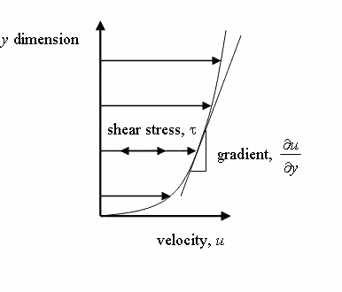

Fig. 1.1

The relationship between the shear stress and the velocity field was that the shear stresses are directly proportional to the velocity gradient. The constant of proportionality is called the coefficient of dynamic viscosity.

*u*

*y*

###### UNITOF VISCOSITY

* In mkssystemunitofviscosityiskgf-sec/m2
* Incgssystemunitofviscosityis dyne-sec/cm2
* InS.Isystemunitofviscosityis Newton-sec/m2

###### Kinematicviscosity:-

Another coefficient, knownas the kinematic viscosity( \nu  , Greek nu) is defined as the ratio ofdynamic viscosity and density.

I.et,=viscosity/density

Inmks &S.Isystemunit ofkinematic viscosityis meter2/sec In cgs system unit of kinematic viscosity is stoke.

###### SURFACETENSION:-

Surface tension is defined as the tensile force acting on the surface of a liquid in contact with a gas or on the surface between two immiscible liquids such that the contact surface behaves like a membrane under tension. The magnitudeofthis forceperunit lengthofthe freesurfacewillhavethesame valueasthesurfaceenergyper unit area. It is denoted byGreek letter sigma(σ). InMKS units, it is expressed as kgf/mwhile inSI unitis N/m.

Itisalso definedas [force](http://en.wikipedia.org/wiki/Force)per unit [length,](http://en.wikipedia.org/wiki/Length) orof[energy](http://en.wikipedia.org/wiki/Energy)per unit [area.](http://en.wikipedia.org/wiki/Area) Thetwo areequivalent—but whenreferring to energyper unit ofarea, people use the term [surface energy](http://en.wikipedia.org/wiki/Surface_energy)—which is a more generalterminthe sense that it applies also to [solids](http://en.wikipedia.org/wiki/Solid) and not just liquids.

###### Capillarity:-

Capillarity is defined as a phenomenon of rise or fall of a liquid surface in a small tube relative to the adjacent general level of liquid when the tube is held vertically in the liquid. The rise of liquid surface is known as capillary rise while the fall ofthe liquid surface is knownas capillary depression. Itis expressed in terms ofcm or mm of liquid. Its value depends upon the specific weight of the liquid, diameter of the tube and surface tension of the liquid.

###### Pressureanditsmeasurement:- INTENSITY OF PRESSURE:-

Intensityofpressureisdefinedasnormalforceexertedbyfluidatanypointperunitarea.Itisalsocalled specific pressure or hydrostatic pressure

P=df/da

* + - Ifintensityofpressure isuniformover anarea“A”thenpressure forceexerted byfluid equalto MathematicallyF=PA
    - If intensity ofpressure is not uniformor varypoint to point then pressure force exerted by fluid equal to integration of P*A

MathematicallyF=ʃPA

* + - Unitofpressure
      * 1N/m2 =1 Pascal
      * 1KN/m2=1kilo Pascal
      * KiloPascal=1kpa=103Pascal
      * 1 bar=105Pascal= 105N/m2

###### Pascal’slaw:-

Itstatesthatthepressureorintensityofpressureatapointinastaticfluidisequalin alldirection.

###### AtmosphericPressure:-

Theatmosphericairexertsanormalpressureuponallsurfacewithwhichitisincontactanditiscalled atmospheric pressure. It is also called parametric pressure.

Atmosphericpressureatthesealeveliscalledstandardatmospheric pressure.

S.A.P= 101.3KN/m2=101.3kpa= 10.3mofH2O

=760mmofHg

=10.3(millibar)

###### Gaugepressure:-

It is the pressure which measure withhelp ofpressure measuring device inwhichatmospheric pressuretakenas datum.

Theatmosphericpressureonscaleismarkedas zero.

###### Absolutepressure:-

Anypressuremeasureaboveabsolutezeropressureiscalledabsolute pressure.

###### Vacuum pressure:-

Vacuumpressureisdefinedasthepressurebelowtheatmospheric pressure.

###### RELATIONSHIPBETWEENABSOLUTEPRESSURE,GAUGEPRESSURE,VACUUMPRESSURE:-

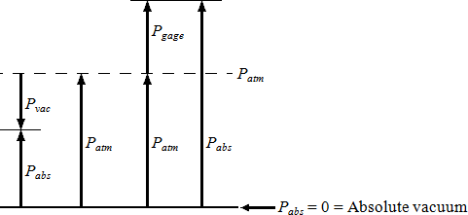

Fig. 1.2

* + - Equations

|  |  |
| --- | --- |
| *P*gage=*P*abs–*P*atm | gauge pressure |
| *P*vac=*P*atm– *P*abs | vacuumpressure |
| *P*abs= *P*atm+ *P*gage | absolutepressure |

* + - Nomenclature

|  |  |
| --- | --- |
| *P*abs | absolutepressure |
| *P*gage | gage pressure |
| *P*vac | vacuumpressure |
| *P*atm | atmosphericpressure |

###### PressureHead:-

**pressurehead** isthe [internalenergy](http://en.wikipedia.org/wiki/Internal_energy)ofa [fluid](http://en.wikipedia.org/wiki/Fluid) duetothe [pressure](http://en.wikipedia.org/wiki/Pressure) exertedonitscontainer.Itmayalsobe called**staticpressurehead**orsimply**statichead** (butnot **staticheadpressure**).Itismathematically expressed as:

*p**p*

 *g*

where

\psiis pressure head ([Length](http://en.wikipedia.org/wiki/Length),typically inunits ofm);

pis fluid [pressure](http://en.wikipedia.org/wiki/Pressure) ([force](http://en.wikipedia.org/wiki/Force) perunit[area,](http://en.wikipedia.org/wiki/Area)oftenas [Pa](http://en.wikipedia.org/wiki/Pascal_(unit))units);and

\gammaisthe[specificweight](http://en.wikipedia.org/wiki/Specific_weight) ([force](http://en.wikipedia.org/wiki/Force)perunit [volume,](http://en.wikipedia.org/wiki/Volume)typicallyN/m3units) \rho is the [density](http://en.wikipedia.org/wiki/Density)ofthe fluid ([mass](http://en.wikipedia.org/wiki/Mass) per unit [volume,](http://en.wikipedia.org/wiki/Volume) typically kg/m3)

gis [accelerationdue to gravity](http://en.wikipedia.org/wiki/Standard_gravity)(rateofchange ofvelocity,given in m/s2)

Ifintensityofpressureexpress intermsofheight of liquidcolumn, whichcausespressure isalso calledpressure head.

Mathematically,*h*=*P/w*

###### PressureGauges:-

Thepressureofafluidis measuredbythefollowingdevices:-

1. manometers
2. mechanicalgauges

**Manometers**:-Manometers are defined as the devices usedformeasuring the pressure ata pointin a fluidby balancing the column of fluid bythe same or another column ofthe fluid. Theyare classified as:

1. Simple manometers
2. Differentialmanometer

**Mechanicalgauges**:-mechanicalgaugesaredefinedasthedevicesusedformeasuringthepressureby balancing the fluid column bythe spring or dead weight. The commonly used mechanical gauges are:-

1. Diaphragmpressure gauge
2. Bourdontube pressure gauge
3. Deadweightpressuregauge
4. Bellowspressuregauge

###### PRESSUREEXERTEDONIMMERSEDSURFACE:-

**Hydrostaticforcesonsurfaces**:-

Hydrostaticmeansthestudyofpressureexertedbyaliquidatrest.Thedirectionofsuchpressureisalways perpendicular to the surface to which it acts.

###### ForcesonSubmergedSurfacesinStaticFluids

Thesearethefollowingfeaturesofstaticsfluids:-

* Hydrostaticverticalpressuredistribution
* Pressuresatanyequaldepthsina continuousfluidare equal
* Pressureatapointactsequallyinalldirections(Pascal'slaw).
* Forcesfromafluid onaboundaryactsat rightanglestothatboundary.

###### Fluidpressureonasurface:-

Pressureis defined asforce perunitarea. If a pressure*p* acts on a small area*δA*then the force exerted on that area will be

*F**p**A*

###### TOTALPRESSURE:-

Totalpressure is defined as the force exerted by a static fluid on a surface when the fluid comes in contact with the surface.

Mathematically**totalpressure**,

*P=p1a1+p2a2+p3a3………….*

Where,

* p1,p2,p3=Intensitiesofpressureondifferentstripsofthesurface,and
* a1,a2,a3=Areasofcorrespondingstrips.

Thepositionofanimmersed surfacemay be,

* Horizontal
* Vertical
* Inclined

###### TotalPressureOnAHorizontalImmersedSurface

Consideraplanehorizontalsurfaceimmersedinaliquidasshowninfigure1.

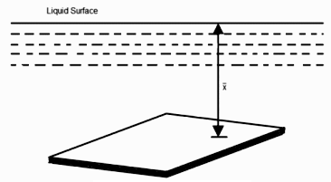

Fig. 1.3

* Specificweightoftheliquid
* *A*Areaoftheimmersed surfaceinin2
*  =Depthofthehorizontalsurface fromthe liquid levelin meters We know that the **Total pressure** on the surface,

**P**=Weightoftheliquidabovetheimmersedsurface

=Specificweightofliquid*Volumeofliquid

=Specificweightofliquid *Areaofsurface* Depthof liquid

=*A**kN*

###### TotalPressureOnAVerticallyImmersedSurface

Consideraplaneverticalsurface immersedinaliquidshowninfigure2.

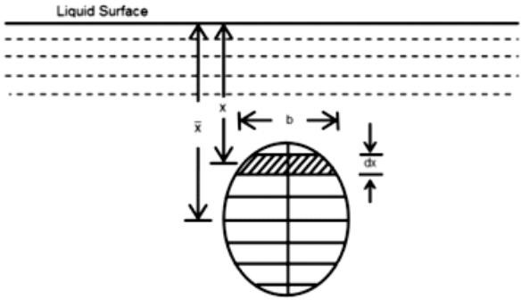

Fig. 1.4

Letthewhole immersedsurface isdivided intoanumberofsmallparallelstripesasshowninfigure. Here,

* Specificweightoftheliquid
* A= Totalarea oftheimmersedsurface
* =Depthofthecenterofgravityoftheimmersedsurfacefromtheliquidsurface

Now,considera strip ofthickness*dx*,width*b* andatadepth*x*fromthefreesurface oftheliquid.

Theintensityofpressureonthestrip=

andtheareaofstrip =b.d*x*

\thereforePressureonthestrip =Intensityofpressure* Area=.bd*x*

Now,Totalpressureonthesurface,

*P**wx*.*bdx*.

*w**x*.*bdx*

But,*w**x*.*bdx*=Momentofthesurfaceareaabouttheliquidlevel=*Ax*

*P**wAx*

###### Centreofpressure:-

The center of pressure is the point where the total sum of a [pressure](http://en.wikipedia.org/wiki/Pressure) field acts on a body, causing a [force](http://en.wikipedia.org/wiki/Force)to act through that point. The total force vector acting at the center of pressure is the value of the integrated pressure field. The resultant force and center of pressure location produce equivalent force and moment on the body as theoriginalpressure field. Pressure fields occurinbothstatic and dynamic fluid mechanics. Specificationofthe center of pressure, the reference point from which the center of pressure is referenced, and the associated force vectorallows the moment generated about anypoint to be computed bya translation fromthe reference point to the desired new point. It is common for the center of pressure to be located on the body, but in fluid flows it is possible for the pressure field to exert a [moment](http://en.wikipedia.org/wiki/Moment_%28physics%29) on the body of such magnitude that the center of pressure is located outside the body.

**Chapter-II**

# CHAPTER-2

**KINEMATICSOFFLUIDFLOW**

###### Basicequationoffluidflowandtheirapplication:- Energy of a Liquid in Motion:-

The energy, ingeneral, maybe defined as the capacityto do work.Though the energyexits in manyforms, yet the following are important from the subject point of view:

1. Potentialenergy,
2. Kineticenergy,and
3. Pressureenergy.

###### PotentialEnergyofaLiquidParticleinMotion:-

Itisenergypossessed byaliquidparticlebyvirtueofitsposition.Ifaliquidparticleis*Z m*

abovethehorizontal datum (arbitrarily chosen), thepotential energy oftheparticle willbe *Z*

metre-kilogram(brieflywrittenasmkg) per kgofthe liquid. Thepotentialheadofthe liquid,at point,will be *Z* metresof the liquid.

###### KineticEnergyofaLiquidParticleinMotion:-

It is the ehergy,possessedby a liquid particle,by virtue of its motionor velocity.If a liquidparticleis flowingwith a mean velocityof vmetres per second; then the kineticenergyof the particle will be*V2/2g* mkg per kg ofthe liquid. Velocityhead ofthe liquid,at that velocity,will be *V2/2g*metresofthe liquid.

###### PressureEnergyofaLiquid ParticleinMotion:-

Itistheenergy,possessed byaliquidparticle,byvirtueofitsexistingpressure. Ifaliquidparticleis

undera pressureof p kN/m2 (i.e., kPa), thenthe pressureenergyofthe particle-willbe the liquid,wherew is the specificweightofthe liquid.Pressureheadof the liquid

*p*mkgperkg of

*w*.

underthatpressurewillbe

*p*metresoftheliquid.

*w*.

###### TotalEnergyofaLiquidParticlein Motion:-

Thetotalenergyofaliquid,inmotion,isthesumofitspotentialenergy,kineticenergyandpressure energy,Mathematicallytotal energy,

*E=Z+V2/2g*+

*p*mofLiquid.

*w*.

###### TotalHeadofaLiquidParticleinMotion:-

Thetotalheadofa liquidparticle,inmotion,isthesumofitspotentialhead, kineticheadandpressurehead. Mathematically, total head,

*H =Z+V2/2g+*

###### Example

*p*mofliquid.

*w*.

Water is flowingthroughataperedpipehavingenddiametersof150mmand 50 mmrespectively.Findthe dischargeat the larger end and velocityhead at the smallerend, if the velocityof water at the larger end is 2 m/s. Solution.Given:d1= 150mm= 0•15 m;d2= 50 mm= 0•05 mand V1= 2•5 m/s. Dischargeatthe larger end We know that the cross-sectionalarea of the pipe at the larger end,

a1=

(0.15)217.6710-3m2

4

anddischargeatthelarger end,

Q1=a1.v1 =(17.67xl0-3)x2.5 =44.2x10-3m3/s

=44.2Jitres/s Ans.

Velocityhead at thesmallerend

Wealsoknowthatthecross-sectionalareaofthepipeat thesmallerend,

A2=

(0.15)21.96410-3m2

4

Sincethedischargethroughthepipeiscontinuous,therefore

*a1.v1=a2.v2*

or v2=

*a*1.*v*1=*[(17.67x10-3)x2.5]/1.964x10-3=22.5m/s*

*a*2

:.Velocityhead atthesmallerend

*V22/2g=(22.5)2/2* x*9.81=25.8mAns*

###### Bernoulli’sEquation:-

Itstates, “For aperfect incompressibleliquid, flowing inacontinuous stream, thetotalnergy;ofaparticle remainsthe same,while the particlemoves fromone pointto another.”This statement is based on the assumptionthat there are no “lossesdue to friction in the pipe. Mathematically,

Z+V2/2g+

where

*p*= Constant

*w*.

Z=Potentialenergy,

V2/2g=Kineticenergy,and

*p*=Pressureenergy.

*w*.

Proof

Consideraperfectincompressibleliquid,flowingthroughanon-uniformpipeasshowninFig-

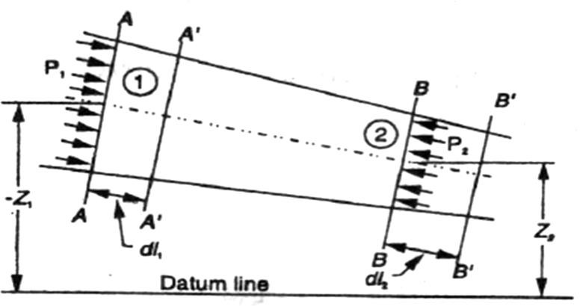

Fig.2.1

Let usconsidertwosections AAandBBofthepipe. Nowlet usassumethatthepipe isrunning fullandthere is a continuityof flow betweenthe two sections.

Let

Z1=HeightofAAabovethedatum, P1=Pressureat AA,

V1=Velocityofliquid atAA,

A1=Cross-sectionalareaofthepipeat AA,and Z2,P2,V2,A2=Correspondingvalues at BB.

Let the liquid betweenthe two sections AAand BB move to A' A'and B'B'throughverysmall lengthsdl1and dl2as shown in Fig. This movementof the liquid between AA and BB is equivalent to the movement'of the liquid betweenAA and A' A' to BB and B' B', the remainingliquidbetween A' A' and BB being uneffected.

Let Wbetheweight oftheliquid betweenAAandA'A'. Sincethe flow iscontinuous,therefore W =wa1dI1=wa2dL2

or a1Xdl1=*W* ...(i)

*w*

Similarly a2dl2=*W*

*w*

a1.dL1=a2dL2 ...(ii)

WeknowthatworkdonebypressureatAA,inmovingtheliquidtoA'A'

=Force xDistance= P1.a1.dL1

Similarly,work donebypressureat BB,inmovingtheliquidto B' B'

=-P2a2dl2

...(Minussignistakenasthe directionofP2isoppositetothatofP1)

:.Totalworkdonebythepressure

=P1a1dl1- P2a2dl2

=P1a1dl1-p2a1dl1 …(a1dl1=a2dl2)

=a1.dl1(P1-P2)=*W*(P1-P2)…(a1.dl1=*W*)

*w w*

Lossofpotentialenergy =W (Z1-Z2)

andagaininkineticenergy =W[(V22/2g)-(V2/2g)]=

1

*W*(v22-v12)

2*g*

Weknowthatlossofpotentialenergy+Workdone bypressure

=Gaininkinetic energy

W (Z1-Z2)+*W*(P1-P2)= *W*(v22-v12)

*w* 2*g*

(Z1-Z2)+(p1/w)-(p2/w)=v22/2g-v12/2g

OrZ1+v12/2g+(p1/w)=Z2+v22/2g+(p2/w) whichprovesthe Bernoulli'sequation.

###### Euler's EquationForMotion

The"Euler'sequationforsteadyflowofan idealfluidalonga streamline isbasedonthe

Newton'sSecondLaw ofMotion.The integrationofthe equationgives Bernoulli'sequationin the formof energyper unit weight ofthe flowingfluid. It is based on the 'followingassumptions:

1. Thefluidisnon-viscous(i.e.,thefrictionallossesare zero).
2. Thefluidishomogeneousandincompressible(i.e.,massdensityofthefluidisconstant).
3. Theflowiscontinuous,steadyandalongthe streamline.
4. Thevelocityofflowisuniformoverthesection.
5. No energyor force (exceptgravityand pressureforces)is involvedin the flow. Considerasteady'flowofanidealfluidalongastreamline.Nowconsiderasmallelement ABof the flowingfluid as shownin Fig.

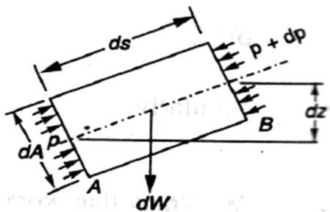Let

dA=Cross-sectionalareaofthefluidelement, ds =Lengthof the fluid element,

dW=Weightofthefluid5!1ement, p=Pressureon the elementat A,

p+dp=Pressureontheelementat B, and v =Velocityof the fluid element.

Weknowthattheexternalforcestendingto acceleratethe fluid elementin the directionof the streamline

=p.dA-(p+dp)dA Fig. 2.2

=-dp.dA

Wealso knowthattheweightofthefluidelement, dW=g.dA . ds

Fromthe geometryofthefigure,wefindthat thecomponentoftheweightofthefluidelement

,inthe directionofflow

= - g . dA . ds cos

=-g.dA.ds() …cos=

=-g.dA.dz

= .dA.ds

,Weseethattheaccelerationofthefluidelement

Now,asperNewton'sSecondLawofMotion,weknowthat Force=Mass xAcceleration

(-dp.dA)-(g.dA.dz-)=.dA.ds

…(dividingbothsideby-)

Or 

Thisis the requiredEuler'sequationfor motionand is inthe formofa differentialequation. Integratingthe aboveequation, '

gz+v2/2=constant



P+wZ+Wv2/2g=constant

+Z+v2/2g=constant(Dividingbyw)

orinotherwords,+Z1+(v12/2g)=+Z2+(v22/2g) which provesthe Bernoulli'sequation.

###### LimitationsofBernoulli'sEquation:-

TheBernoulli's theoremor Bernoulli's equationhasbeenderivedon certainassumptions, whichare rarelypossible.Thus the Bernoulli'stheoremhas the followinglimitations:

1. The Bernoulli'sequationhas been derived under the assumptionthat the velocityof every liquid particle,acrossany cross-sectionof a pipe, is uniform.But, in actual practice,itis not so. The velocityof liquid particlein the centreof a pipeis maximumand gradually decreasestowardsthe wallsof the pipedue to the pipefriction.Thus,whileusingthe Bernoulli'sequation,only the meanvelocityof the liquid shouldbe taken into account.
2. The Bernoulli'sequationhas been derivedunderthe assumptionthat no externalforce, exceptthe gravity force,is acting on the liquid. But,in actual practice,itis not so. There are alwayssome externalforces(suchas pipefrictionetc.)actingonthe liquid,which effectthe flow of the liquid. Thus, while using the Bernoulli'sequation,all such external forces should be neglected.But,ifsorne energy is supplied to, or, extractedfromthe flow, the same should alsobe taken into account.
3. The Bernoulli'sequationhas been derived,under the assumptionthat there is. noloss of energyof the liquidparticlewhileflowing.But,in actualpractice,-it is rarelyso. In a turbulentflow, some kinetic energyis convertedinto heat energy.And in a viscousflow, some energyis lost dueto shear forces.Thus,while usingBernoulli'sequation,all such lossesshouldbe neglected.
4. Ifthe liquid is flowingin a curved path, the energydue to centrifugalforce shouldalso be takeninto account.

###### Example

The diameterof a pipe changes from200 mm at a section5 metres-abovedatum = to 50 mm at a section3 metresabove datum.The pressureof water at firstsectionis 500 kPa. If the velocityof flowat the first sectionis 1 m/s, determinethe intensityof pressureat the secondsection.

Solution.'Gi~en:d1=200 mm=0.2 m;Z1=5 m; d2=50 mm=0.05mz2=3 m;p =500/ kPa = 500 kN/m2and V1=1 mls.

Let

V2=Velocityofflowatsection2,and

P2=Pressureat section2. Weknowthatareaofthepipeat section1 a1=2=31.4210-3m2 and area of pipe at section2 a1=2=1.96410-3m2

Sincethe dischargethroughthepipeiscontinuous,thereforea1.V1=a2.V2

V2==[(31.42-3)]/1.964-3=16m/s

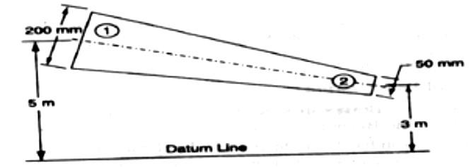

Fig. 2.3

ApplyingBernoulli'sequationforboththeends ofthepipe, Z1 + v12/2g+ (p1/w)=Z2+ v22/2g+(p2/w)

5+(1)2/(2)+500/9.81=3+(16)2/2X9.81+

P2=40x9.81=392.4kN/m2=392.4kPaAns

###### practical ApplicationsofBernoulli's Equation

TheBernoulli's theoremor Bernoulli's equationis the basicequationwhichhas thewidest applicationsin Hydraulicsand AppliedHydraulics.Since this equationis appliedfor the derivation

.ofmanyformulae,thereforeitsclear understandingis veryessential.ThoughtheBernoulli'sequationhas a numberof practicalapplications.yet in this chapterwe shalldiscussits applicationson the following ‘hydraulic devices:

1. Venturimeter.
2. Orificemeter.
3. Pitottube.

###### Venturimeter

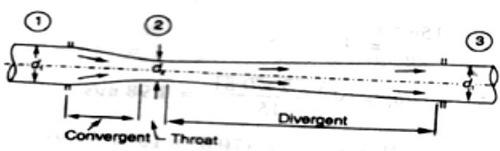

Fig. 2.4

Aventurimeterisanapparatusfor findingoutthedischargeofa liquidflowinginapipe.A- venture meter,in its simplestform, consistsof the followingthree parts:

* 1. Convergentcone.
  2. Throat.
  3. Divergentcone.

###### Convergentcone

Itisashortpipewhichconvergesfromadiameterd1(diameterof thepipe.in whichtheventuremeter is fitted)to asmallerdiameterd2:Theconvergentconeis alsoknownas inletofthe venturi meter.The slope ofthe convergingsides is between1 in 4 or 1 in 5 as shownin Fig.

###### Throat

It isasmallportionofcircularpipeinwhichthediameterd2iskeptconstantasshowninFig.

###### Divergentcone

It isapipe,whichdivergesfromadiameterd2 to alargediameterd1.Thedivergentconeisalso knownas outletofthe venturemeter.The length ofthe divergentcone is about3to 4timesthan that oftheconvergent cone as shown in Fig.

Alittleconsiderationwillshowthattheliquid,whileflowingthroughtheventure meter,is accelerated betweenthe sections1 and 2(i.e., while flowing throughthe convergentcone). As a result ofthe acceleration, the velocityof liquid at section2 (i.e.,atthe throat)becomeshigherthanthat at section1. This increasein velocityresults inconsiderablydecreasingthe pressureat section2.1fthe pressurehead at the throat falls below the separationhead (whichis 2.5 metresof water),then there will be a tendencyof separationof the liquidflow,In orderto avoidthe tendencyof separationat throat,there is alwaysa fixed ratio of the diameterofthroatandthepipe(i.e., dz/dt).Thisratiovaries from1/4to 3/4,butthe most suitablevalue is1/3 to 1/2.

The liquid,while flowingthroughthe venture meter,is decelerated(i.e., retarded)betweenthe sections2 and 3 (i.e., while flowingthrough the divergentcone).As a resultofthis retardation,the velocityof liquid decreaseswhich,consequently,increasesthe pressure.If the pressureis rapidly recovered,then there is every possibilityfor the stream of liquid to break awayfrom the walls of the metredue to boundarylayer effects.Inordertoavoidthetendencyofbreakingawaythestreamofliquid,thedivergentconeismade

sufficientlylonger.Anotherreasonformakingthe divergentcone longeris tominimisethe frictional losses.Duetothesereasons,thedivergentconeis3 to 4times longerthan convergentconeasshownin Fig. **Dischargethrougha Venturi meter**

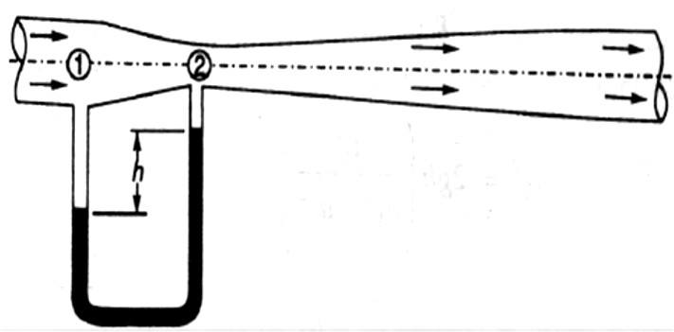Consideraventuremeterthroughwhichsomeliquidisflowingasshownin Fig.

Fig.2.5

Let

P1=Pressureatsection1,

V1=Velocityofwateratsection1, Z1=Datumhead at section1,

a1 =Area ofthe venturi meter at section1, and p2,v2,z2,a2 =Correspondingvaluesat section2.

ApplyingBernoulli'sequationatsections1and2.i.e

Z1+v12/2g+ (p1/w)=Z2+ v22/2g+(p2/w) (1)

Letuspassourdatumlinethroughthe axisoftheventuremeterasshowninFig.

NowZ1=0 andZ2=0

v12/2g+ (p1/w)= v22/2g+(p2/w)

Or (p1/w)-( p2/w)=v22/2g-v12/2g (2)

Sincethedischargeat sections1and2iscontinuous,therefore V1=a2v2/a1(a1v1=a2v2)

V12=a22v22/a12 (3)

Substitutingtheabovevalueofv12inequation(2),

=v22/2g-(a22/a12Xv22/2g)

= v22/2g(1-a22/a12)=v22/2g[(a2-a22)/a12]

1

Weknowthatisthedifferencebetweenthepressureheadsatsections1and2whenthepipeis horizontal,this differencerepresents the venturi head and is denotedbyh.

Or h=v22/2g[(a12-a22)/a12] Or v22=2gh[a12/(a 2-a22)]

1

 v2=[a1/(a12-a22)]

Weknowthatthedischargethroughaventure meter, Q =Coefficientof venturi meterx a2 v2

=C.a2v2=[Ca1a2/(a12-a22)]

###### Example

Aventure meterwitha 150mmdiameterat inlet and 100mmat throat is,laid with its axishorizontalandis used formeasuringthe flowof oil specificgravityO.9. The oil-mercury differentialmanometershows a gauge differenceof200mm. Assumecoefficientof the metre as O.9 Calculatethe dischargein litres per minute.

Solution.Given:d1=150mm=0.15 m;d2=100 mm=0.1 rn;Specificgravityofoil=0.9 h = 200 mm = O.2 m of mercuryandC = 0.98.

Weknowthattheareaatinlet, a1=2=17.6710-3m2

andtheareaatthroat,a2=2=7.85410-3m2

Wealsoknowthat thedifferenceofpressurehead,

H=0.2(13.6-0.9/0.9)=2.82mofoil

andthedischargethroughtheventurimeter, Q= [Ca1a2/(a12-a22)]

=63.9X10-3m3/s=63.9lit/s Ans.

###### 0rificeMetre

Anorificemetreisusedtomeasurethedischargeinapipe.Anorificemetre,inits simplest

form,consistsofa platehavinga sharpedged circularhole knownas an orifice.This plateisfixedinside a pipe as shownin Fig. c A mercurymanometeris insertedto knowthe difference

ofpressuresbetweenthe pipe an?the throat(i.e.,orifice).

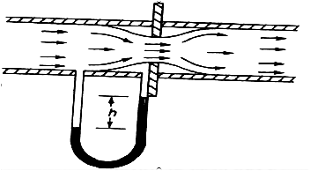

Let

h=Readingofthemercurymanometer, P1= Pressureat inlet,

V1= Velocity ofliquidat inlet, a1= Area ofpipe at inlet, and P2,v2,a2=Correspondingvalues

atthethroat. Fig.2.6

NowapplyingBernoulli'sequationfor inletofthe pipe and the throat, Z1 + v12/2g+ (p1/w)=Z2+ v22/2g+(p2/w) ………(i) (p1/w)-(p2/w)=v22/2g-v12/2g

Orh= v22/2g-v12/2g=1/2g(v22-v12) ………(ii) Sincethe dischargeis continuous,thereforea1.v1= a2v2

V1=a2/a1Xv2orv12=a22/a12X v22

Substitutingtheabovevalueofv12inequation(ii)

h=1/2g(v22-a22/a12Xv22)= v22/2gX(1-a22/a12)=v22/2g[(a12-a22)/a12]

 v22=2gh[a12/(a12-a22)]orv2=2gh[a1/(a12-a22)] We know that the discharge,

Q=Coefficientoforificemetrexa2.v2

=[Ca1a2/(a12-a22)]

**Example.** An orificemetreconsistingof 100 mm diameterorificein a 250 mm diameter pipehas coefficientequalto0•65. The pipedeliversoil (sp. gr. 0•8). The pressuredifferenceonthe two sides of the orifice plate is measured bya mercury oildifferential inano meter.lfthedifferentialgauge reads 80 mmof mercury,calculatethe rate of flowin litresls.

Solution. Given:d2=100mm=0.1 m;d1=250 mm=o.25m;C=0.65 ;Specificgravity of oil = 0.8 and h = 0.8 m of mercury.

We knowthattheareaofpipe,

a1=2=49.0910-3m2

and area ofthroat

a2=2=7.85410-3m2

Wealsoknowthatthepressuredifference, h =0.8[(13.6-0.8)/0.8]=12.8 m of oil

andrateof flow,

Q=[Ca1a2/(a12-a2)]

2

=8210-3m3/s=82lit/s Ans

###### Pitot Tube.

A Pitottube is an instrumentto determinethe velocityof flow at the requiredpointin a pipe or a stream. In its simplestform,a pitot tube consistsofa glass tube bent a through90° as shownin Fig.

The lower endofthe tube faces the directionofthe flow as shown inFig. Theliquid rises up inthe tube due to thepressureexerted by the flowingliquid.By measuringthe rise of liquid in the tube,we can find out the velocityof the liquid flow.

Leth=Heightoftheliquidinthe pitot tube abovethe surface,

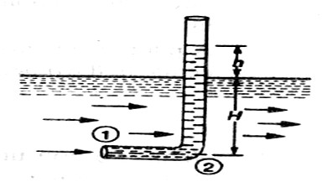

Fig.2.7

H=Depthoftubeintheliquid,andv =Velocity oftheliquid.

Applying Bernoulli's equation forthesections 1 and2,

H+v2/2g=H+h …..(z1=z2)

h=v2/2g

v =2gh

###### Example.

Apltottubewasinsertedinapipetomeasu!ethe velocityofwater in it. If( waterrises the tube is 200 mm, findthe velocityof water.

Solution. Given: h=200mm= 0.2m.

Weknowthatthevelocity ofwaterinthepipe, v = 2gh = (2 x 9.81x 0.2)= 1.98m/sAns.

###### RateofDischarge

Thequantityofa liquid, flowingper secondthroughasectionofapipeor achannel,isknown as therateof dischargeor simplydischarge.It isgenerallydenotedbyQ. Now consider a liquid flowingthrougha pipe.

Let,a=Cross-sectionalareaofthepipe, and v =Averagevelocityof the liquid,

:.Discharge,Q=Area×Averagevelocity=a.v

**Notes:**1.Iftheareaisinm2andvelocityinm/s,thenthedischarge, Q=m2 x m/s = m3/s = cumecs

1. Rememberthat1m3=1000litres.

###### EquationofContinuityofaLiquidFlow

Ifan incompressible liquidiscontinuouslyflowingthroughapipeor achannel(whosecross- sectionalarea may ormay not be constant)the quantityof liquid passingper secondis the sameat all sections.This is knownas the equationofcontinuityofa liquid flow. It is the first and fundamentalequationof flow.

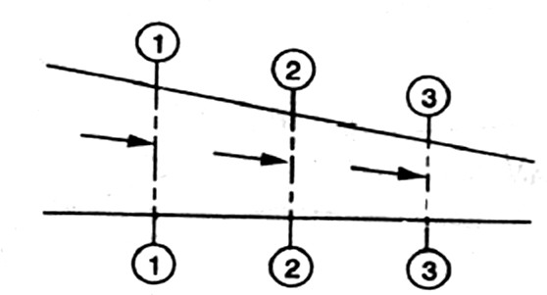

Fig.2.8

###### CONTINUITYOFALIQUIDFLOW

Considerataperingpipethroughwhichsomeliquidisflowingasshownin Fig

Let ,a1=Cross-sectionalareaofthepipeat section1-1, and v1=Velocityof the liquidat section1-1,

Similarly,*a2,v2*=Correspondingvaluesat section2-2, and *a3,v3*=Correspondingvaluesatsection3-3.

Weknowthatthetotalquantityofliquidpassingthroughsection1-1,

Q1=*a1.v1* (i)

Similarly,totalquantityofliquidpassingthroughsection2-2,

Q2=*a1.v1* (ii)

andtotalquantityoftheliquidpassingthroughsection3-3,

Q3=*a3.v3* (iii)

Fromthe law ofconservationof matter, weknowthat the totalquantityof liquidpassingthroughthe sections 1-1, 2-2 and 3-3 is the same. Therefore

Q1=Q2=Q3=.......ora1.v1= a2.v2=*a3.v3*.......andsoon.

**Example**: Water isflowingthroughapipeof100mmdiameterwithanaveragevelocity

10 m/s. Determinetherateofdischargeofthewaterin litres/s.Also determinethevelocityofwater At the otherend ofthe pipe,ifthe diameterofthe pipe is gradually changedto 200 mm.

**Solution**.Given:d1=100mm=0.1m;V1=10m/sand d2=200mm=0.2m.

*Rateof discharge*

Weknowthatthecross-sectionalareaofthepipe atpoint1, a1= x(0.1)2=7.854x10-3 m2

andrateofdischarge,Q =*a1.v1*=(7.854x10-3)x10=78.54X10-3m3/s

=78.54litres/s **Ans.**

*Velocityofwateratthe otherendof the pipe*

Wealso knowthat cross-sectionalareaofthepipeatpoint2, a2=x(0.2)2=31.42x10-3 m2

andvelocityofwaterat point2 ,v2==((78.54X10-3)/(31.42x10-3))=2.5m/s **Ans.**

###### FlowoverNotches:-

A notchis a deviceused for measuringtherate of flow of a liquidthrougha smallchannelor atank. It maybedefinedasanopeningintheside of a tankora smallchannelin such away thattheliquid surfacein the tankor channelis belowthetopedgeoftheopening.

Aweiris a concreteormasonrystructure, placedin an openchanneloverwhichtheflowoccurs.It is generallyin theformof verticalwall,witha sharpedge at thetop,runningall thewayacrossthe open channel.Thenotchis ofsmallsizewhiletheweiris ofa biggersize.Thenotchis generally made of metallicplatewhileweiris madeofconcreteor masonrystructure.

1. NappeorVein.Thesheetofwaterflowingthrougha notchorovera weiris calledNappeor Vein.
2. Crestor Sill. Thebottomedgeof a notchor a topof a weiroverwhich thewater flows, is known as thesillor crest.

###### ClassificationOfNotchesAndWeirs:-

Thenotchesareclassifiedas:

I.According totheshape oftheopening:

1. Rectangularnotch,
2. Triangularnotch,
3. Trapezoidalnotch,and
4. Steppednotch.

2.Accordingtotheeffectofthe sidesonthenappe:

(a)Notchwithendcontraction.

lb)Notchwithout endcontraction orsuppressed notche,

Weirs are classifiedaccordingto the shapeof theopeningthe' shape ofthe crest,theeffectofthesides onthe nappeandnatureofdischarge.Thefollowingareimportantclassifications.

###### DischargeOverA RectangularNotch OrWeir

Theexpressionfor dischargeoverarectangularnotchor weiristhesame.

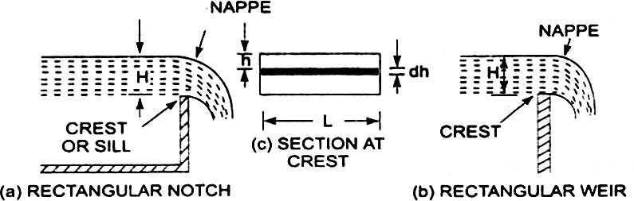

Fig.2.9

###### Rectangularnotchand'weir:-

Considera rectangularnotchor weir providedin a channelcarryingwateras shownin Fig Let H = Head of wateroverthe crest L = Lengthof the notch or weir

Thetotaldischarge,*Q=cd3/2*

###### Problem-1

Findthe dischargeof water flowing over a rectangular notch0/2 In lengthwhenthe constantheadover the notchis 300 mm. Take *cd* = 0.60.

Solution.Given:

Lengthofthenotch,L=2.0m

Headovernotch,H=300m=0.30 m Cd=0.06

Discharge*Q=cd3/2*

*=1.5*m3/s

= 3.5435x0.1643=0.582m3/s.Ans,

###### Problem2

Determinetheheightofarectangularweiroflength6mtobebuiltacrossaRectangularchannel.The maximumdepthofwaterontheupstreamsideoftheweiris 1.8manddischargeis 2000litres/s.TakeCd=

0.6andneglectendcontractions. Solution.Given:

Length of weir, L=6m Depthofwater,H1=1.8m

Discharge,Q=2000litIs=2m3/s Cd/=0.6

LetHistheheightofwaterabovethecrestofweirandH2=height ofweir

Thedischargeovertheweirisgivenbytheequation.

*Q=cd3/2*

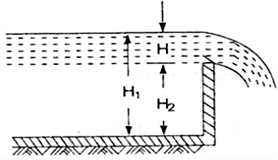

2=3/2

=10.623H3/2

=H3/2= Fig.2.10

H=2/3=0.328m

Heightofweir,H2= H1-H

= Depthofwateronupstreamside-H

=1.8-.328=1.472m.Ans.

###### DischargeOverA Triangular NotchOrWeir:-

The expressionfor the dischargeovera triangularnotchor weir is the same. It is derivedas : Let H = head of waterabovethe V- notch

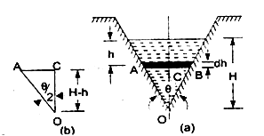

= angle of notch

Totaldischarge,Q=d5/2

ForarightangleVNotch,ifCd=0.6

0,tan



=1.417

5/2

Discharge,Q= 5/2

Fig.2.11

###### Problem-1

Findthedischargeoveratriangularnotchofangle60°whentheheadoverthe V-notchis 0.3 m. AssumeCd= 0.6.

Solution.GivenanAngleofV-notch,e=60° Head over notch, H=0.3 m

Cd=0.6

Discharge,QoveraV-notchisgivenbyequation Q=d5/2

d5/2

= 0.8182x0.0493=0.040m3/s.Ans,

###### Problem-2

Water flowsovera rectangularweir1 m wideat a depthof 150 mm and afterwards passesthrougha triangularright-angledweir. Taking Cdforthe rectangularand triangularweiras 0.62 and 0.59 respectively,findthe depthover the triangularweir.

Solution.Given:

Forrectangularweir.Length=L=1m Depth of water, H= 150mm=0.15m Cd= 0.62

Fortriangularweir.  =90°

Cd= 0.59

Letdepthovertriangularweir =H1

Thedischargeovertherectangularweir ISgivenbyequation

*Q=cd3/2*

=3/2

=0.10635m3/s

The same dischargepassesthroughthe triangularright-angled weir.But discharge.Q. is givenby the equation

Q=d5/2



0.10635= 15/2 { 0and H=H1 }

= 15/2

=1.3936H15/2

H15/2= H1=(0.07631)0.4=0.3572 m ,Ans

###### DischargeOverA Trapezoidal NotchOrWeir:-

Atrapezoidalnotch or weir is a combinationof a rectangularand triangularnotchor weir. Thus thetotal dischargewillbe equalto the sumofdischargethrougharectangularweir or notch and dischargethrough a triangularnotch or weir.

LetH=Heightofwateroverthenotch

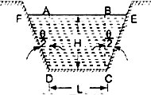L=Lengthofthecrestofthenotch

Cd1= Co-efficientor discharge. for rectangularportioo ABCD ofFig. Cd2=Co-efficientofdischargefortriangularportion[FADandBCE]

The-dischargethroughrectangularportionABCDisgivenby

or Q1=d13/2

Thedischargethroughtwo triangular notchesFDA andBCE is equalto the dischargethrougha single triangularnotch of angle e and it is given by equation

Q2=d25/2

DischargethroughtrapezoldalnotchorweirFDCEF= Q1+ Q2

=d1L3/2d25/2

**Problem-1** Find the dischargethroughatrapezoidalnotchwhichis 1 mwide at the tap and 0.40 matthe bottomandis 30 cm in height.Thehead ofwaterOnthe notchis 20 cm.AssumeCdfor rectangular portion= 0.62 while fortriangularportion= 0.60.

Solution.Given:

Top width AE=1 m

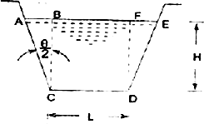Basewidth, CD=L=0.4 m

Headofwater, H=0.20m

For rectangularportion, Cd1=0.62 From ,we have



= Fig.2.12

Dischargethroughtrapezoidalnotchisgivenbyequation Q= d13/2+d25/2



= x0.62x0.4xx(0.2)3/2+5/2

=0.06549+0.02535=0.09084m3/s=90.84litres/s.Ans

###### DischargeOverA SteppedNotch:-

A steppednotchis a combination of rectangularnotches.Thedischarge through 'steppednotchis equal to the sum of the discharges' throughthe differentrectangularnotches.

ConsiderasteppednotchasshowninFig.

Let *H1*=Heightofwaterabovethecrestofnotch(1).

L1=Lengthofnotch1,

*H2,*L2and *H3,*L3 are corresponding valuesfor notches2and 3 respectively. Cd=Co-efficientof dischargefor all notches

TotaldischargeQ=Q1+Q2+Q3

Fig.2.12

Q=d113/2-H23/2]+d223/2-H3/2]+Cd333/2

3

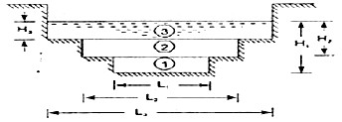

**Problem** Fig.2.13

Fig.1showsasteppednotch.FindthedischargethroughthenotchifCd forall section= 0.62.

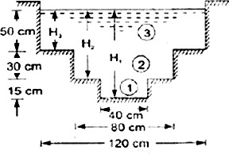Solution. Given:

L1=40cm,L2=80cm, L3= 120cm

H1=50+30+15=95crn, H2=80 cm,H3=50 cm, Cd=0.62

TotalDischarge,Q=Q1+Q2+Q3where



Q1= d1 13/2-H23/2]

= [953/2-803/2]

=154067cm3/s =154.067 lit/s Fig.2.14 Q2= d223/2-H33/2]

=[803/2-503/2]

=530141cm3/s

=530.144lit/s

Q3=Cd333/2

=3/2

=776771cm3/s

=776.771lit/s

 Q=Q1+Q2+Q3

=154.067+530.144+776.771

=1460.98lit/s Ans.

###### VelocityOfApproach

Velocityofapproachis definedasthe velocity withwhichthe water approachesor reaches theweir or notch beforeit flows over it. Thusif Vais the velocityofapproach, then an additionalhead haequal

toVa2/2gdueto velocityofapproach,is acting onthe water. flowingover the notch. Theninitialheight of water over the notch becomes(H+ ha)and final heightbecomesequalto ha,' Thenall the formulaeare changedtaking into considerationof velocity of approach.

The velocityof approach,Vais determinedby findingthe discharge over the notch or weir neglecting velocityof approach.Thendividingthe -discharge-bythecross-sectionalareaof thechannel.on the' upstreamside of the weir or notch,the velocityofapproach is obtained . Mathematically,

Va=

Thisvelocityof approachis usedto findan additionalhead(ha= Va2/2g).Againthe dischargeis calculatedand above process is repeatedfor more accuratedischarge.

Dischargeover arectangularweir,with velocityofapproach

=d[(H1+ha)3/2-ha3/2]

###### Problem:-

Water isflowing in a rectangular channelof1mwideand0.75mdeep.Findthedischargeovera rectangularweir ofcrest length60 cm ifthe head ofwateroverthe crest ofweir is

20cmandwaterfromchannel flowsovertheweir.TakeCd=0.62.Neglectendcontractions.Take

velocityofapproachintoconsideration. Solution.Given:

Areaofchannel, A= Widthxdepth=1.0x0.75=0.75 m2 Lengthof weir, L = 60 cm = 0.6 m

Headofwater,H1=20cm=0.2m Cd= 0.62

Dischargeoverarectangularweirwithoutvelocityofapproachisgivenby Q=Cd13/2

=3/2

=0.0982m3/s

velocityofapproachVa==Additional head ha=Va2/2g

=(0.1309)2/2

Thendischargewithvelocityofapproachisgivenbyequation

Q=d[(H1+ha)3/2-ha3/2]

=3/2-(0.00087)3/2]

=1.098[0.09002-.00002566]

=1.098x 0.09017

=0.09881m3/s.Ans

###### TypesofWeirs :-

Thoughthereare numeroustypesofweirs,yetthe followingareimportantfromthe subjectpointofview

:

1. Narrow-crested weirs,
2. Broad-crested weirs,
3. Sharp-crested weirs, 4: Ogeeweirs,and

5. Submergedor drownedweirs.

###### DischargeoveraNarrow-crestedWeir:-

Theweirsare generallyclassifiedaccordingtothewidthoftheircrestsintotwotypes.i.e. narrow-crested weirsand broadcrestedweirs.

Letb= Widthofthe crestofthe weir,and

H=Heightofwaterabovetheweircrest.

If2bis lessthanH,theweir iscalleda narrow-crestedweir. Butif2bis morethanH. it iscalleda broad-crested weir.

A narrow-crested weir is hydraulically similarto an ordinaryweir or to a rectangular weir .Thus,thesame formulafordischargeoveranarrow-crestedweirholdsgood,whichwederivedfroman ordinaryweir

.

Q =XCd.LxH3/2

Where,Q=Dischargeovertheweir,

Cd=Coefficientofdischarge, L=Lengthof the weir, and

H=Heightofwaterlevelabove thecrestofthe weir.

**Example** A narrow-crestedweir of10metres long is dischargingwater under a constant head of 400mm. Find discharge over the weir in litresls. Assumecoefficientof discharge as 0.623.

**Solution.**Given:L=10m;H=400 mm=0.4mandCd=0.623. We know that the dischargeover the weir,

Q=X Cd.Lx H3/2

=x0.623x10(0.4)3/2

=46.55m2/s=4655lit/s

###### DischargeoveraBroad-crested Weir:-

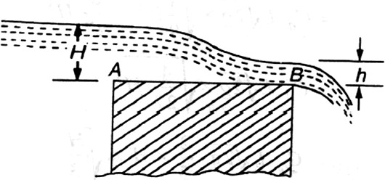

Fig.2.15

Broad-crestedweir

Considera broad-crestedweirasshowninFig.LetAandBbetheupstreamand downstreamendsof the weir.

Let H =Headofwaterontheupstreamside ofthe weir (i.e.,at A), h=Headofwateronthedownstreamsideoftheweir (i.e., at B), v=Velocityofthewateronthedownstreamsideoftheweir

(i.e.,atB),

Cd=Coefficientofdischarge,and L=Lengthof the weir.

###### Q=1.71Cd.LH3/2

**Example**A broad-crestedweir20m longis dischargingwaterfroma reservoirin tochannel.Whatwill bethedischargeovertheweir,iftheheadofwaterontheupstreamand downstreamsidesis 1mand0.5 m respectively?Take coefficient of discharge forthe flowas 0.6 .

**Solution.**Given:L=20 m;H=1m; h= 0.5 mandCd= 0.6.

Weknowthatthedischargeovertheweir, Q = CdL .h



=0.6x2.0x0.5x m3/s

=6x3.13=18.8m3/s **Ans.**

###### Dischargeovera Sharp-crestedWeir :-

Itis a specialtype of weir,havinga sharp-crestas shownin Fig.The water flowingover thecrestcomes in contactwiththecrest -lineandthenspringsupfromthecrestandfallsasa trajectoryas shownin Fig.

Ina sharp-crestedweir,thethicknessoftheweiris keptlessthanhalfoftheheightofwateronthe weir.i.e.,

b<(H/2)

where ,b=Thicknessoftheweir,

and H=Heightofwater,abovethe crestoftheweir.

Thedischargeequation,forasharpcrestedweir,remainsthesameasthatofarectangularweir.i.e.,

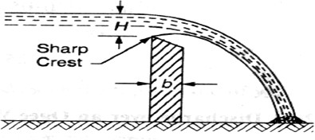

Fig.2.16

###### Sharp-crested weir:-

Q =XCd.LxH3/2

Where, Cd= Coefficientof discharge, andL=Lengthofsharp-crestedweir

**Example** Ina laboratoryexperiment,water flows over a sharp-crestedweir200mmlong underaconstant headof75mm. Findthe discharge over the weir in litres/s,if Cd= 0.6.

**Solution.** Given:L=200mm=0.2 m;H=75mm=0.075 mandCd=0.6. We know that the dischargeover the weir,

Q =XCd.LxH3/2

=3/2

=0.0073m3/s=7.3 litres/s.**Ans.**

###### Discharge overanOgee Weir :-

It isaspecialtypeofweir,generally,usedasaspillwayofadamasshownin Fig.

,The crestofanageeweirslightlyrisesupfromthe

pointA ,(i.e., crestof thesharp-crested weir) andafter reachingthemaximum riseof0.115H (where H is the heightofa waterabove the pointA)fallsin a parabolic formas shownin Fig.

gg 35

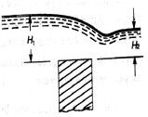

Thedischargeequationforanageeweirremainsthesameasthatofarectangularweir.i.e.,

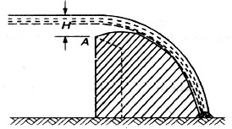Q =XCd.LxH3/2

WhereCd=Co-efficientofdischargeand L= Length of an ogee weir

Fig.2.17

###### Example

Anogeeweir 4metreslonghas500mmheadofwater.Findthedischargeovertheweir,ifCd=0.62.

.

Solution.Given:L=4m;H=500mm=0.5mandCd=0.62. We know that the dischargeover the weir,

Q=X Cd.Lx H3/2

=X 0.62X 42X 9.81X(0.5)3/2m3/s

=7.323x0.354=2.59m3/s=2590litres/s Ans

###### DischargeoveraSubmerged orDrownedWeir:-

Whenthewaterlevelonthedownstreamsideofaweirisabovethetopsurfaceofweir,itisknowna submergedordrownedweir as shown in Fig

Thetotaldischarge,oversuchaweir,is foundoutbysplittingup theheightofwater, abovethesillofthe weir, into two portionsas discussedbelow:

Let H1=Heightofwaterontheupstreamsideoftheweir, and H2=height of wateron the downstreamside

oftheweir.

Fig.2.18

The dischargeover the upperportionmay be considered as a free dischargeundera headof water equal to (H1– H2).And the dischargeover the lower portion may be considered as a submerged dischargeundera headofH2. Thusdischargeover the free portion(i.e.,upperportion),

*Q1=XCd .Lx(H1-H2)3/2*

###### Submergedweir :-

andthedischargeoverthesubmerged(i.e.,lowerportion), Q2= Cd. L. H2.1-H2)

:.Totaldischarge, Q=Q1+ Q2

**Example**A submerged sharp crested weir 0.8 metre high stands clear across a channel havingverticalsides and a width of 3 meters. The depth of water in the channel of approach is 1.2 meter.And10 meters downstreamfromtheweir, thedepthofwateris1 meter.Determine the discharge over the weir in liters per second.Take Cdas 0.6.

**Solution.**Given:L=3mandCd = 0.6.

Fromthegeometryoftheweir, we findthat thedepth of wateron the upstreamside,

H1=1.25 -0.8=0.45 mand depthofwateronthedownstreamside, H2= 1 -0.8 = 0.2 m

Weknowthat thedischargeoverthefreeportionofthe weir

*Q1=XCd.Lx (H1-H2)3/2*

=3/2

= 5.315 x 0.125 = 0.664m3/s=664 liters/s ...(i) and dischargeover the submergedportionof the weir,

Q2= Cd.L.H2.1-H2)

=0.6x3x0.22x9.81(0.45- 0.2)m3/s

= 0.36x2.215=0.797m3/s = 797liters/s ...(ii)

:.Totaldischarge:Q=Q1+ Q2= 664+797=1461liters/s **Ans.**

* 1. **FlowoverWeirs:-**

An openchannelis a passagethroughwhichthe waterflowsunderthe forceof gravity -atmospheric pressure.Orinotherwords,whenthefreesurfaceoftheflowingwaterisin contact,with theatmosphere

asin the case of a canal,a sewer or an aquaduct,theflowis said to be through an open channel.A channel may be coveredoropen at the top. As a matter offact, the flow ofwaterin an open channel,is not due to any pressureas in the case of pipe flow. But it is due to the slope the bed of the channel.Thusduring the constructionofa channel,a uniform slope in its bed is providedto maintainthe flow ofwater.

###### Chezy'sFormulaforDischargethroughanOpenChannel :-

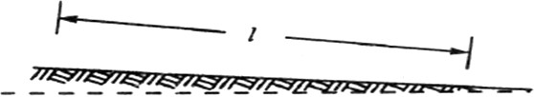

Fig.2.19

###### Slopingbedof achannel:-

Consideranopenchannelofuniformcross-sectionandbedslopeasshowninFig. Let

I=Lengthofthechannel, A=Area of flow,

v=Velocityofwater,

p=Wettedperimeterofthecross-section,m=

f=Frictionalresistanceperunit areaat unit velocity,andi =Uniformslope in the bed.

m=  ……..(knownashydraulic meandepthorhydraulicradious)  Discharge Q= A X v=ACmi

###### Example.

A rectangularchannel is 1. 5 metres deep and 6metres wide. Find the discharge through channel, when it runs full. Take slope ofthe bed as 1in 900 and Chezy's constant as 50.

Solution. Given: d=1.5m;b=6 m;i=1/900andC=50. We know that the area of the channel,

A=b.d=6x1.5=9m2

andwettedperimeter, D=b+2d=6+(2x1.5) =9m

:. Hydraulicmeandepth,m= =1m and the dischargethroughthe channel,

Q =ACmi=9x50(1X1/900)=15m3/s Ans.

###### ManningFormulaforDischarge:-

Manning,aftercarryingoutaseriesof experiments,deducedthefollowingrelationforthevalueof Cin Chezy'sformulafor discharge:

C=1/6

whereNistheKutter'sconstant Nowwe see that the velocity,

v=Cmi=MXm2/3Xi1/2where

M=1/NandisknownasManning'sconstant. Nowthe discharge,

Q =AreaxVelocity= Ax1/Nxm2xi1/2

=AxMxm2/3xi1/2

###### Example

An earthenchannelwith a3 m widebaseand sideslopes1 : 1 carrieswaterwith adepth of 1 m.Thebed slope is 1in 1600. Estimatethe discharge.Take value ofN in Manning's formulaas 0.04.

Solution.

Given:b = 3 m; Side slopes = 1 : 1; d = 1 m; i=1/1600andN=0.04. We know that the area of flow,

A=x(3+5)x1=4m2

andwetted perimeter,

P=3+2X(1)2+(1)2 =5.83m

 hydraulicmeandepthm=A/P=4/5.83=0.686m We know that the discharge through the channel

Q =Area xVelocity= Ax1/Nxm2/3xi1/2

=4X 1/0.04X0.6862/3X(1/1600)1/2

=1.945m3/sAns

###### ChannelsofMost EconomicalCross-sections:-

A channel,whichgivesmaximumdischargefor a givencross-sectionalarea and bed slopeis called a channelof most economicalcross-section.Orinother words, it is a channelwhich involves least excavation for a designedamountof discharge.A channelof most economicalcross-sectionis, sometimes:also definedas a channelwhichhasa minimumwettedperimeter;so thatthereis a minimumresistanceto flow and thus resultingin a maximumdischarge.From the above definitions,

it is obviousthat whilederivingthe conditionfor a channelof mosteconomicalcross-section,the cross- sectionalarea is assumedtobeconstant.The relationbetweendepth and breadthofthe section is found out to give the maximumdischarge.

Theconditionsfor maximumdischargefor thefollowingsectionswillbe dealtwithin the succeeding pages:

1. Rectangularsection,
2. Trapezoidalsection,and
3. Circularsection.

###### ConditionforMaximumDischarge throughaChannelofRectangularSection:-

Arectangularsectionis, usually, not providedin channelsexceptinrockysoils wherethe facesofrockscan standvertically.Thougha rectangularsectionis not of

muchpracticalimportance,yetweshalldiscussitforitstheoreticalimportanceonly.

Considera channelofrectangularsectionasshown inFig.

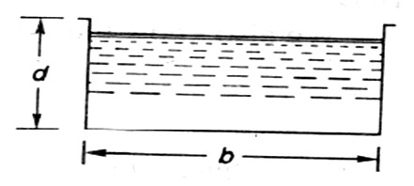Let

b=Breadthofthechannel,and d =Depthof the channel.

A=bXd

DischargeQ=Axv=ACmi m=A/P

=d/2

Fig.2.20

Hence,for maximumdischargeormaximumvelocity,thesetwoconditions(i.e., b=2dand m=d/2)shouldbe used for solvingthe problemsofchannelsofrectangularcross-sections.

###### Example

Arectangularchannelhas across-sectionof8 squaremetres.Finditssizeand dischargethroughthe most economicalsection,if bed slope is1 in 1000.Take C = 55.

Solution.Given:A=8 m2

i=1/1000=0.001andC=55.

Sizeofthechannel Let

b=Breadthofthechannel,and d =Depth of the channel.

Weknowthat forthemost economicalrectangularsection, b =2d

:.Area(A)8=bX d= 2dXd=2d2

=b=2m

And b=2d=2 X 2= 4 m Dischargethroughthechannel

Wealso knowthat forthemost economicalrectangularsection,hydraulicmeandepth, m=d/2=2/2=1 m

and the dischargethroughthe channel,

Q= ACmi= 8x551X 0.001m3/s

=440x0.0316=13.9m3/s,Ans.

###### ConditionforMaximumDischargethroughaChannelof Trapezoidal Section:-

A trapezoidalsectionis alwaysprovidedin the earthenchannels.The side slopes,in a channel of trapezoidalcross-sectionare provided,so that the soil can stand safely.Generally,the side slope in a particularsoil is decidedafter conductingexperimentson that soil. In a soft soil, flatter side slopes

shouldbeprovidedwhereasina harderone,steepersideslopesmaybeprovided. considera channel of trapezoidal cross-section ABCD as shownin FIg.

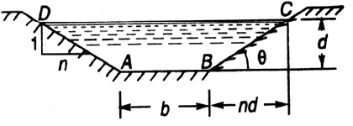

Fig.2.21

Let

b=Breadthofthechannelatthebottom, d =Depth of the channel and

=sideslope (i.e.,1 verticalto nhorizontal)

Hence, formaximum discharge ormaximum velocity these two

(i.e.,b+2nd/2=dandm=d/2)shouldbeusedfor solving problemsonchannelsof trapezoidalcross-sections.

###### Example.

A most economicaltrapezoidalchannelhas an area of flow 3.5 m2 dischargeinthe channel,whenrunning 1 metredeep.Take C = 60 and bed slope1 in 800.

**Solution.**Given:A= 3.5 m2 ;d=1 m;C=60andi= 1/800.

Weknowthatforthe most economicaltrapezoidalchannelthehydraulicmeandepth m = d/2= 0.5 m

anddischargeinthechannel,

Q=A.C. = 5.25m3/sAns.

###### Example.

Atrapezoidalchannelhavingsideslopesof1 : 1 and bed slopeof1 in1200 isrequiredtocarryadischarge of1800 m3/min.Findthe dimensionsofthe channel for cross-section.Take Chezy'sconstantas50.

###### Solution.

Givensideslope(n)=1

(i.e.1verticaltonhorizontal),

i=1/1200,Q=180m3/min=3m3/sec and C = 50

Letb=breadth ofthechannelof itsbottomandd=depthofthewaterflow.

Weknowthatforminimumcrosssectionthechannelshouldbemosteconomicalandforeconomical trapezoidal section half of the top width is equal to the slopping side. i.e.

b+2nd/2=dor b = 0.828d

Area A = d X (b + nd) = 1.828d2

Weknowthatinthecase ofamosteconomicaltrapizodialsectionthehydraulicmeandepthm=d/2

Anddischargethroughthechannel(Q)=A.C.=1.866d5/2d5/2 =3/1.866 = 1.608

Ord=1.21m

b = 0.828 d = 0.828 X 1.21 = 1 m ANS

###### ConditionforMaximumVelocitythroughaChannelofCircularSection:-

Considerachannel'ofcircularsection,dischargingwaterundertheatmosphericpressureshowninFig. Let r =Radiusof the channel,

h=Depthofwaterinthe channel,and

2=Total angle(in radians) subtended at the centre by the water Fromthegeometryofthefigure,wefind that thewettedperimeterofthechannels,

P=2 ...(i)

andareaofthesection,throughwhichthewaterisflowing,

A =r2- = r2 (-) …(ii) We know that the velocityof flow in an open channel,

Q=A.C.

Weknowthat the velocityofflowinanopenchannel,v= C

###### Problem: Find the maximum velocity of water in a circular channel of 500 mm radius, if the bed slope is1 in 400. Take manning’s constant as 50.

**Solution:-**

Givend= 500mm= 0.5morr= 0.5/2= 0.25m,i=1/400andM= 50

Let**2**=totalangle (inradian)subtendedbythe watersurfaceatthe centreofthechannel.

Nowweknowthatformaximumvelocity,theanglesubtendedbythewatersurfaceatthecentreofthe channel.

**2**=257030’or=128.750=128.75X= 2.247rad

Area of flow, **A**= r2 (  -) =171m2 And perimeter P = 2r  = 1.124m

hydraulic meandepthm= A/P=0.171/1.124=0.152m Andvelocityofwaterv=MXm2/3Xi½= 0.71m/s ANS

**CHAPTER-3 PUMPS**

###### CentrifugalPumps:-

The hydraulic machines whichconvertthe mechanicalenergyto hydraulic energyare called pumps. The hydraulic energy is in the form of pressure energy. If the mechanical energy is converted,into pressure energy by means of centrifugal force acting on the fluid, the hydraulic machine is called centrifugal pump.

The centrifugal pump works on the principle of forced vortex flow which means that when a certain mass of liquid is rotated by an external torque, the rise in pressure head of the rotating liquid takes place. The risein pressure head at anypoint of the rotatingliquidis proportionalto the square oftangentialvelocityof the

*v*2 2*r*2

liquidatthatpoint(i.e. , riseinpressurehead= *or*

2*g* 2*g*

) .Thusattheoutletoftheimpeller,whereradiusis

more , the risein pressurehead will bemore&theliquid will bemore& the liquid will be discharged atthe outlet with a high pressure head. Due to this high pressure head, the liquid can be lifted to a high level.

###### MainPartsOfACentrifugal Pump:-

Thefollowingsarethemainpartsofacentrifugal pump:

* + 1. Impeller
    2. Casing
    3. Suctionpipewithafoot valve&astrainer
    4. DeliveryPipe

Allthemainpartsofthe centrifugalpumpare showninFig19.1

1. **Impeller**: The rotating part of a centrifugal pump is called ‘impeller’. It consistsof a series ofbackward curved vanes. The impeller is mounted on a shaft which is connected to the shaft of an electric motor.
2. **Casing:** The casing of a centrifugal pump is similar to the casing of a reaction turbine. It is an air-tight passage surroundingthe impeller &isdesigned insuchawaythat thekineticenergyofthewater discharged atthe outlet ofthe impeller is converted into pressure energybeforethe water leaves the casing &entersthe delivery pipe. The following three types of the casings arecommonly adopted:
   1. Volute**casing** asshownin Fig.19.1
   2. VortexcasingasshowninFig.19.2(a)
   3. Casingwithguidebladesasshownin Fig.19.2(b)
3. **Volute casing** as shown in Fig.3.1the Volute casing, which is surrounding the impeller. It is of spiral type in which area of flow increases gradually. The increase in area of flow decrease velocity of flow. Decrease in velocityincreases the pressure ofwater flowing throughcasing. it has been observed that in case of volute casing, the efficiency of pump increases.

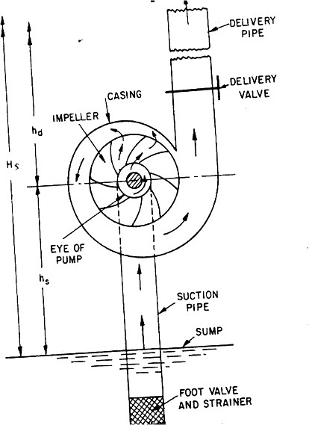

Mainpartsofacentrifugalpump Fig. 3.1

1. **Vortex casing**. if a circular chamber is introduced between the casing and impeller as shown in fig.3.1,the casing isknownas vortexcasing .by introducing the circular chamber, lossofenergydue to formationofeddies is reduced to a considerable extent. thus efficiency ofpump is morethan the efficiencywhen onlyvolute casing is provided.
2. **Casing with guide blades**.This casing is shown in fig.3.1 inwhichthe impeller is surrounded by a series of guide blades mounted on a ring which is known as diffuser.the guide vanes are designedin which a way that the water from the impellerenters the guide vanes without stock. Also the area of guide vanes increases, thus reducing the velocity of flow through guide vanes and consequently increasing the pressure of water. the water from guide vanes then passes through the surrounding casing which is in most of cases concentric with the impeller as shown in fig.3.1.
3. **suction pipe with foot-valve and a strainer:** A pipe whose one end is connected to the inlet of pump and other enddips into water in a sump is known as suction pipe. A footvalve which is a non-return valve or one –way type valve isfitted at lower end of suction pipe. Footvalveopens only in upward direction. A strainer is also fitted at lower end of suction pipe.

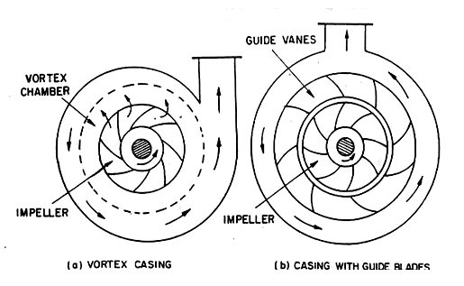

fferenttypeofcasing

Di

Fig:3.2

1. **Delivery pipe:** a pipe whose one end is connected to outlet of pump and other end delivers water at a required height is known as delivery pipe.

**Efficiencies of a centrifugal pump:** Efficiencies of a centrifugal pump: In case of a centrifugal pump, the power is transmitted from the shaft of the electric motor to the shaft of the pump& then to the impeller. From the impeller, the power is given to the water. Thus power is decreasing from theshaft of the pump to the impeller & then to the water. The following are the importantefficiencies of a centrifugal pump:

* 1. Manometricefficiencies*man*
  2. Mechanicalefficiencies*m*
  3. Overallefficiencies*o*

1. **Manometric Efficiencies***man***:**The ratio of the manometric head to the head imparted by the impeller to the water is known as manometric efficiency. It is written as

maxManometrichead∕Headimpartedbyimpellerto water

=*Hm* 

*Vw*2*u*2*g*

*gHm*.................

*Vw*2*u*2

The impeller at the impeller of the pump is more than the power given to the water at outlet of the pump. The ratio of the power given to water at outlet of the pump to the power available at the impeller, is known as manometric efficiency.

Thepowergiventowaterat outlet ofthepump=*WHmkW*

1000

Thepowerattheimpeller=

*W**Vw*2*u*2*kW*

*g* 1000

= *WHm*

  1000 

*gHm*

max *W Vu*

*V* *u*

*w*22

*g* 1000

*w*2 2

###### Mechanical efficiencies:-

The power at theshaft of the centrifugal pump is more than the power available at the impeller of the pump . Theratio of the power available at the impeller to the power at the shaft of the centrifugal pump is known as mechanical efficiency. It is written as

*m*Power attheimpeller∕Power attheshaft

Thepower attheimpellerinkW=Workdonebyimpeller per second∕10000

*W**Vw*2*u*2

*g* 1000

*W**Vw*2*u*2

 

WhereS.P.=ShaftPower

*g*1000...............

*m S*.*P*.

###### Overallefficiencies*o*

It isdefined astheratio ofpoweroutput ofthepump to thepower input to thepump . Thepower output of the pump in kW

=*WHm*

1000

Powerinputtothepump=Powersuppliedbytheelectricmotor

=S.P. ofthepump

*WH*

*m*

1000

=*o*

*S*.*P*.

................

*man**m*....................

**Problem 3.1:** The internal & external diameters of the impeller of a centrifugal pump are 200mm & 400mmrespectively. The pump isrunningat 1200r.p.m. Thevaneanglesofthe impeller at inlet &outlet are 200& 300 respectively. The water enters the impeller radially & velocity of flow is constant. Determine the velocity of flow per metre sec.

**Solution:I**nternalDia.Ofimpeller,=D1=200mm=0.20m **E**xternalDia.Ofimpeller,=D2=400mm=0.40m Speed N=1200r.p.m

Vaneangleatinlet,200

Vaneangleatoutlet,300

Water enter sradially means,900

Velocityofflow,=*Vf*1*Vf*2

and*Vw*10

Tangentialvelocityofimpelleratinlet&outletare,

*u**D*1*N*

1 60

*u**D*2*N*

2 60

.20120012.56*m*/*s*

60

.40120025.13*m*/*s*

60

Frominletvelocitytriangle,

tan

*Vf*1

*u*

1

*Vf* 2 12.56

*Vf*1 12.56tan12.56tan204.57*m*/*s V f* 2*V f*1  4.57*m*/ *s*

**Problem 3.2: A** centrifugal pump delivers water against a net head of 14.5 metres & a design speed of 1000r.p.m.The values are back to an angle of 300 with the periphery. The impeller diameter is 300mm & outlet width 50mm. Determine the discharge of the pump if manometric efficiency is 95%.

**Solution:**Nethead,Hm=14.5m Speed, N =1000r.p.m

Vaneangleatoutlet,300

Impellerdiametermeansthediameteroftheimpelleratoutlet

Diameter,

*D*2300*mm*0.30*m*

Outletwidth,

*B*250*mm*0.05*m*

Manometricefficiency, *man* 95%=0.95 Tangential velocity of impeller at outlet, *u*2

*D*2*N*

60

.30100015.70*m*/*s*

60

Nowusing equation



*gHm*

max

*Vw*2*u*2

0.95

9.8114.5

*Vw*215.70

*Vw*2

0.9514.5

0.9515.70

9.54*m*/*s*

Fig.3.3

Referto fig(3.3). Fromoutletvelocitytriangle, wehave

tan

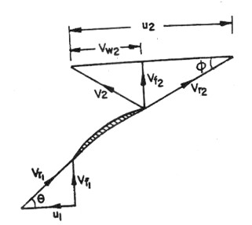

*Vf*2

(*u*2*Vw*2)

tan300

*Vf*2

(15.709.54)

*Vf*2

6.16

*V*  6.16tan300 3.556*m*/*s Disch*arg*e**Q* *D*2*B*2*Vf*2

*f*2

0.300.053.556*m*3/*s*0.1675*m*3/*s*

* 1. **ReciprocatingPump:-**

###### Introduction:-

We havedefinedthepumpsasthe hydraulic machineswhichconvertthemechanicalenergyto hydraulicenergy which is mainly inthe formofpressure energy. Ifthe mechanicalenergyis converted into hydraulic energy(or pressure energy) bysucking the liquid into a cylinder inwhicha pistonis reciprocating (moving backwards and forwards ), which exerts the thrust onthe liquid & increases its hydraulic energy (pressure energy), the pump is known as reciprocating pump.

###### Mainpartsofa reciprocatingpump:-

The followingarethemainpartsofareciprocatingpumpasshowninfig(3.4)

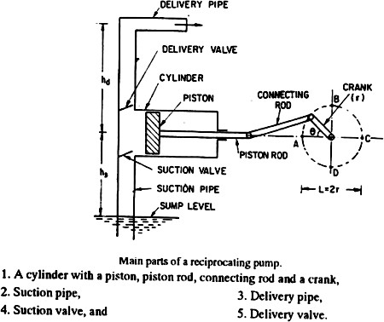

Fig. 3.4

**DischargethroughaReciprocatingPump:**Considerasingleactingreciprocatingpumpasshowninfig().

LetD=dia.Ofthecylinder

A=C/sareaofthepistonor cylinder

= 

r= Radius of crank N=r.p.mofthecrank

L=Lengthofthe stroke=2*r

hs=heightoftheaxisofthecylinderfromwatersurfaceinsump

hd=Heightofthedeliveryoutlet abovethecylinderaxis(also calleddeliveryhead) Volume of water delivered in one revolution or discharge of water in one revolution

=Area*Lengthofstroke=A*L

Number of revolution per second, =

Dischargeofthepump persecond ,Q=Dischargeinonedirection×No.ofrevolutionpersecond

=A×L=  …………………………….

Wt.ofwaterdelivered persecond,W=

*gQ**gALN*

60

……………………………

**Work done by Reciprocating Pump** :Work donebythe reciprocating pump per sec. is given bythe reaction as

lifted

Workdoneper second=Weightofwater liftedpersecond×Totalheightthroughwhichwateris

=*W**hs**hd*

Where*hs**hd*=Totalheightthroughwhichwateris lifted

Fromequation()Weight,Wis givenby*W**gALN*

60

SubstitutingthevalueofWinequation()weget Work done per second =

*gALN**h*

60 *s*

*hd*



…………………………………………

Powerrequiredtodrivethepump,inkW =

=*gALN**hs**hd**kW*

*g**ALN**hs**hd*

601000

60,000

…………………………

###### Classificationofreciprocatingpumps:

**T**hereciprocatingpumpsmay beclassifiedas:

1. Accordingto thewaterbeingincontactwithonesideorbothsidesofthepiston,and
2. Accordingtothenumber ofcylinders provided

Ifthewaterisincontactwithone sideofthepiston,the pumpisknownassingle-acting.Ontheotherhand,

Ifthewaterisincontactwithbothsidesofthepiston,thepumpiscalleddouble–acting.Hence, classification according to the contact of water is:

1. Single-actingpump
2. Double–actingpump

Accordingtothenumber ofcylinder provided,thepumpsareclassified as:

* 1. Singlecylinderpump
  2. Doublecylinderpump
  3. Triplecylinderpump

Reference:BOOK:R.KBANSAL

R.SKHURMI

IRRIGATION **CHAPTER-1 HYDROLOGY**

**HYDROLOGICCYCLE**

**Introduction**

Water canoccur inthreephysicalphases:solid, liquid, and gas andis foundinnatureinallthese phases in large quantities. Depending upon the environment of the place of occurrence, water can quickly change its phase.

The hydrologic cycle can be visualized as a series of storages and a set of activities that move water among these storages. Among these, oceans are the largest reservoirs, holding about 97% of the earth’s water. Of the remaining 3% freshwater, about 78% is stored in ice in Antarctica and Greenland. About 21% of freshwater on the earth is groundwater, stored in sediments and rocks below the surface of the earth. Rivers, streams, and lakes together contain less than 1% of the freshwater on the earth and lessthan 0.1% of all the water on the earth.

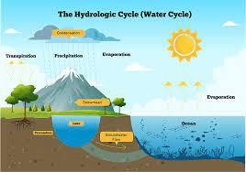

**MeasuringtheIntensityofRainfall**

**Themeasurementoftheamountofrainoveragivenperiodoftimeiscalledthe *intensityof rain*. It is measured in terms of height the rainwater will cover if it stays where it falls.And, the measurement is expressed in millimeters.**

**The device most commonly used to measure rain is a simple cylindrical funnel with a marking scale on the side. The device is called a *rain gauge*. Modern weather stations useTippingBucket RainGauge whichalsoworksonthesameprincipleofmeasuringthe height of rainwater falling at a certain location.**

**Basedonintensityrainfallisclassifiedintothreegroups.They areasfollows:**

1. **LightRainrangesbetween0to2.5mm**
2. **ModerateRainvariesbetween2.6mmto7.6mm**
3. **HeavyRainmeansrainfallabove7.6mm**

**RainfallismeasuredbyRainGaugeintheunitsmillimeters.** **Types of Rainfall based on Origin**

**Basedontheirorigin,rainfallcan beofthreetypesnamely–Convectionalrainfall, Orographic or relief rainfall and Cyclonic or frontal rainfall.**

1. **Convectionalrainfall**

**Thistypeofrainfallisseenpredominantlyinthe**[**equatorialregions**](https://dashamlav.com/equator-location-and-the-countries-it-passes-through/)**andinteriorparts**

**of[continentsinthenorthern hemisphere](https://dashamlav.com/continents-world-map-area-countries-population/).Thistypeofrainfallnormallyoccursin** [**summer**](https://dashamlav.com/seasons-causes-types-classification-effect-diagram/)**or the hotter part of the day. Hot air rises up in convection current and forms cumulus clouds which pours down as heavy rain with lightning and thunder. Convectional rainfall does not last long.**

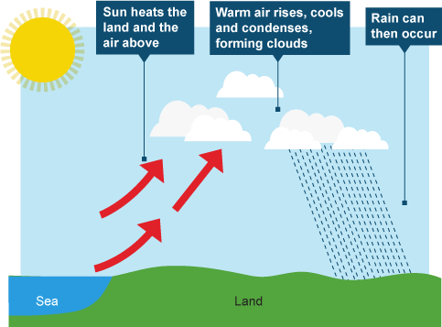

1. **Orographicrainfall**

**This is the type of rainfall is also known as Relief Rainfall and is associated with** [**mountains**](https://dashamlav.com/highest-mountains-peaks-on-earth/)**. Themaincharacteristicoforographicrainfallisthat itgivesthemajorityoftherainfalltothe windward side of the mountain while the leeward side often remains dry and rainless. This type of rain happens when clouds come across mountains and need to rise up. As the cloud rises up, the temperature cools and condenses moisture which forms bigger droplets of water within the cloud. The time these clouds cross the mountain their temperature increases which in turn increases their capacity to absorb moisture. And, hence the leeward side does not get the rain.**

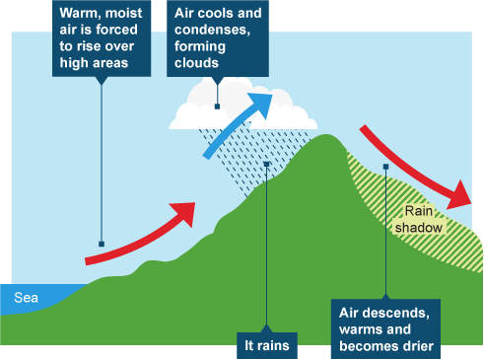

1. **Cyclonicrainfall**

**Also known as frontal rainfall. The cyclonic rain, as the name suggests, occurs along the fronts of a cyclone. This type of rainfall is formed when two air masses with different density,temperatureandhumiditymeetataplace.Asthe warmairrises,moisturepresent init condenses to form altostratus clouds.Cyclonicrainfall falls graduallyfora fewhoursto a few days.**

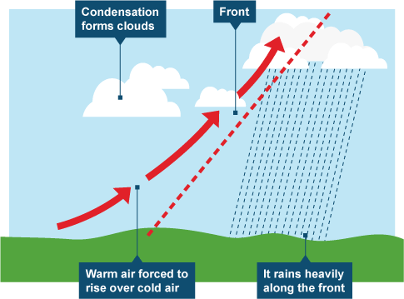

**Hyetograph**

A **hyetograph** is a [graphical representation](https://en.wikipedia.org/wiki/Graphical_representation)of the distribution of [rainfall](https://en.wikipedia.org/wiki/Rainfall)intensityover time. For instance, in the 24- hour rainfall distributions as developed by the Soil Conservation Service (now the NRCS or [National ResourcesConservation Service](https://en.wikipedia.org/wiki/National_Resources_Conservation_Service)), rainfall intensity progressively increases until it reaches a maximum and then gradually decreases.Wherethismaximum occursandhow fastthemaximum isreachediswhatdifferentiatesone distribution from another. One important aspect to understand is that the distributions are for design storms, not necessarily actual storms.

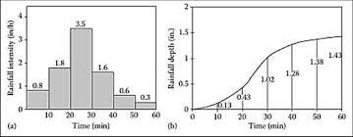

**WhataretheDifferentTypesofRainGauges?** **The Standard Rain Gauge**

The recording of rainfall using the standard or funnel rain gauge is generally done manually. These gaugesworkbycatchingthefalling raininafunnel-shapedcollectorthatisattachedtoa measuring tube. The area of the collector is 10 times that of the tube; thus, the rain gauge works by magnifying the liquid by a factor of 10.

Magnifyingthe raininthiswayallows precisemeasurements downtoaone-hundredthofan inch. Amounts that exceed the tube capacity are caught in the outer shell of the gauge, allowing the recorder to pour out the liquid in the tube and fill it back up if needed.

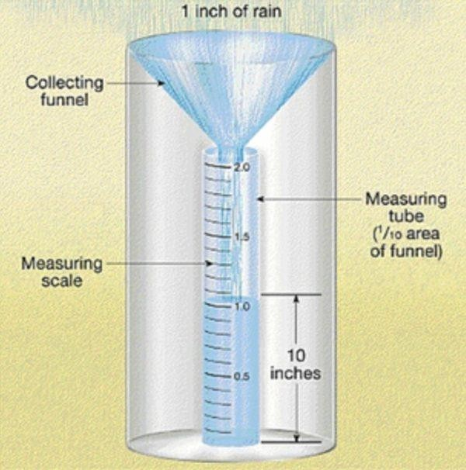

**TheTippingBucketRain Gauge**

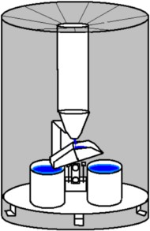Theoperationofatippingbucketraingaugeisquitedifferentfromthestandardgauge.The receiving funnel leads to one of two small buckets. Filling of one bucket occurs at one- hundredthofaninch.Theresultisa “tipping”oftheliquidintotheoutershellofthe gauge, triggering the second bucket to take its place. The process then repeats itself, allowing for precise measurementof rainfall intensity andamount. This gauge has becomestandardfor wireless [weather stations](https://www.maximum-inc.com/product-category/best-weather-stations).

TheWeighingRainGauge

The universal weighing rain gauge is optimal for climatology use. This is because of a vacuum thataccountsfortheeffectsofwind,allowingmoreraintoenterthe gauge.Thesegaugesare very precise in measuring rainfall intensity as the weighing mechanism at the bottom of the collector can be used to measure depth and time simultaneously. Recording is carried out much in the same way as the older versions of the tipping bucket gauges**.**

**Catchmentarea**

Acatchmentisanareaoflandwhere watercollects whenitrains,oftenboundedbyhills.As the water flows over the landscape it finds its way into streams and down into the soil, eventually feeding the river**.**

TypesofRunoff• Surfacerunoff –Portionof rainfall(afteralllossessuchasinterception,infiltration,depressionstorage etc. are met) that enters streams immediately after occurring rainfall – After laps of few time, overland flow joins streams – Sometime termed prompt runoff (as very quickly enters streams)

* Subsurfacerunoff–Amountof rainfallfirstenterintosoilandthenflowslaterallytowardsstreamwithoutjoining water table – Also take little time to reach stream

**CHAPTER-2**

**WATER REQUIREMENTOFCROP**

Need and classification of irrigation- historical development and merits and demerits of irrigation- types of crops-crop season-duty, delta and base period- consumptive use of crops- estimation of Evapotranspiration using experimental and theoretical methods.

##### Irrigation-Definition

* + Irrigationisanartificialapplicationofwatertothesoil.
  + Itisusuallyusedtoassistthegrowingofcropsindryareasandduringperiods of inadequaterainfall.

##### Needofthe Irrigation

* + Indiaisbasicallyanagriculturalcountry,andallitsresourcesdependontheagricultural.
  + Waterisevidentlythemostvitalelementintheplantlife.
  + Waterisnormallysuppliedtotheplantsbynaturethroughrains.
  + However,thetotalrainfallinaparticularareamaybeeitherinsufficient,orill-timed.
  + Systematicirrigationsystem–Collectingwaterduringtheperiodofexcessrainfall& releasing it to the crop when it is needed.

##### Less rainfall:

* + Artificialsupplyisnecessary
  + Irrigation work may be constructed at a place where more water is available & than conveythe water where there is less rainfall.

##### Nonuniformrainfall:

* + Rainfallmaynotbeuniformoverthecropperiodintheparticulararea.
  + Rains may be available during the starting period of crop but no water may be available atend, with the result yield may be less or crop may be die.
  + Collection ofwater during the excess rainfall & suppliedtothe cropduringthe period whenthere may be no rainfall.

##### Commercialcropswithadditionalwater:

* + Rainfallmaybesufficienttoraisetheusualcropbutmorewatermaybenecessary

forraisingcommercial&cashcrop.(Sugarcane,Tea,Tobacco,cotton,cardamom,&indigo)

##### Controlledwatersupply:

* + Yieldofthecropmaybeincreasedbytheconstructionofproperdistributionsystem

##### BenefitsofIrrigation:

* + Increaseinfoodproduction
  + Protectionfromfamine
  + Cultivationofcashcrop(Sugarcane,Tobacco,&cotton)
  + Additiontothewealthofthecountry
  + Increasetheprosperityofpeople
  + Generationofhydro-electricpower
  + Domestic&industrialwatersupply
  + Inlandnavigation
  + Improvementofcommunication
  + Canalplantations
  + Improvementinthegroundwaterstorage
  + Generaldevelopmentof thecountry.

##### TypesofIrrigationORClassificationofIrrigation:

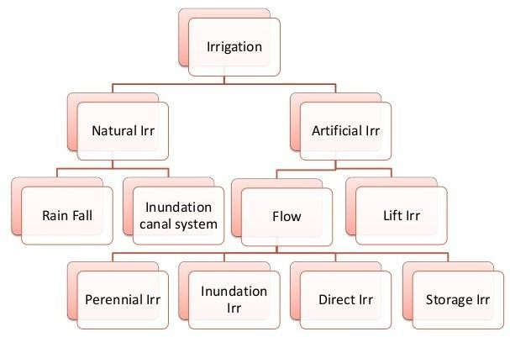

**NaturalIrrigation**

* + Noengineeringstructureisconstructed.

##### RainfallIrrigation

* + Rainfallisonlyusedforraisingcrops.

##### Inundationcanalsystem

* + FloodwaterisutilizedforIrrigationpurposebyproperlydirectionflowofwater.

##### ArtificialIrrigation

* + Properlydesignedengineeringstructureareconstructed.

##### Flowirrigation

* + Waterflowstotheirrigatedlandbygravity.
  + Watersourcesistobehigherlevelthantheirrigatedland.

##### Perennialirrigation:

Water is supplied according to the requirements throughout the crop period through storage canal head works & Canal distribution system.

##### Inundationirrigation:

* + Landsaresubmerged&throughlyfloodedwhenfloodsoccurintheriver.
  + Landsareallowedtodrainoff&thecroparesown.
  + Nowthesoilretainssufficientmoistureforthecropstogrow.

##### Directirrigation:

* + WaterisdirectlydivertedtothecanalfromtheriveriscalledDirectirrigation.
  + Dischargeintherivershallbehigherthanthewaterrequirementduringthecropperiod.
  + A low diversion weir or a barrage is constructed across the river to rise the waterleveland divert the same to the canal.
  + Direct irrigation can be adopted only where there is enough flow in the river to providesufficientquantityofwaterrequiredforirrigationthroughoutthecropperiod.

##### StorageIrrigation:

* + Riverflowisnotperennialorinsufficientduringcropperiod,StorageIrrigationis adopted.
  + Adamisconstructionacrosstherivertostorewaterinthereservoir.
  + In some area rain water that run off from a catchment area is stored in tanks and is usedfor irrigation during the crop period.

##### LiftorwellIrrigation:

* + Waterisliftedupbymechanicalsuchaspumpetcormanualtosupplyforirrigation.
  + Liftirrigationisadoptedwhenthewatersourceislowerthantheleveloflandsto beirrigated.

##### HistoricaldevelopmentofIrrigation

* + Historically,civilizationshavebeendependent ondevelopmentofirrigatedagriculture.
  + Archaeological investigationhasidentifiedevidence of irrigationin **Mesopotamia,Ancient Egypt &Ancient Persia** (at present Iran) as far back as the 6th millennium BCE.
  + In the **“Zana”** valley of the Andes Mountain in **Peru**, archaeologists found remains of three irrigation canals radiocarbon dated from the 4th millennium BCE, the 3rd Millennium BCE& the 9th century CE,These canals are the earliest record of irrigation in the new world.
  + The **Indus valley** civilization in Pakistan & North India (from 2600 BCE) also had an early canal irrigation system. Large scale agriculture was used for the purpose of irrigation.
  + There is evidence of **ancient Egyptian** Pharaoh Amenemhet-III in the 12th dynasty (about 1800 BCE) using the natural lake of the Faiyum Oasis as a reservoir to store surpluses of water for use during the dry seasons, the lake swelled annually from flooding of the Nile.
  + The irrigation works of **ancient Sri Lanka**, the earliest dating from about 300 BCe, in the reign of King Pandukabhaya & under conditions development for the next thousand years, were one of the most complex irrigation systems of the ancient world.
  + In the Szechwan region **ancient China** the Dujiangyan Irrigation System was built in 250BCE to irrigate a large area & it still supplies water today.
  + In the **Americas**, extensive irrigation systems were created by numerous groups in prehistoric times. One example is seen in the recent archaeological excavations near the SantaCruzRiver inTucson,Arizona. Theyhave locateda village site dating from 4000 years ago.

##### PresentstatusofIrrigation:

* + In the middle of 20th century, the advent of diesel & electric motors led for the first timetosystemthatcouldpump groundwateroutofmajoraquifersfasterthanitwasrecharged.
  + This can lead to permanent loss of aquifer capacity, decreased water quality, ground subsidence & other problems.
  + The largest contiguous areas of high irrigation density are found in North India & Pakistan along the rivers Ganges & Indus, in the Hai He, Huang He & Yangtze basins in China, along the Nile River in Egypt & Sudan, in the Mississippi-Missouri river basin & in parts of California.

##### DevelopmentalAspectsofIrrigation:

Irrigationispracticedtomaintainthedifferentdevelopmentalparameters.Thoseare:

1. Tomakeupforthesoilmoisturedeficit.
2. Toensureaproper&sustainedgrowthofcrops.
3. Tomakeharvestsafe.
4. Tocolonizethecultivablewastelandforhorizontalexpansionofcultivation.
5. Toshiftfromseasonalcultivation.
6. Topromotemoreintensivecultivationbymultiplecropping.
7. To improve thelevel of agriculturalproductivity by acting asan agentfor adoption ofmodern technology.

**Advantagesofirrigation**

Advantagesofirrigationcanbedirectaswellasindirect.

1. **DirectBenefits**
   * Thegrower hasmany choicesof crops andvarieties andcan goformultiplecropping forcultivation
   * Cropplantsrespondtofertilizerandotherinputsandtherebyproductivityishigh.
   * Qualityofthecropisimproved.
   * Highereconomicreturnandemploymentopportunities.Itmakeseconomydroughtproof.
   * Development ofpisciculture andafforestation. Plantation israisedalongthe banks of canalsand field boundaries.
   * Domestic water supply, hydel power generation at dam site and means of transportwherenavigation is possible.
   * Preventionofdamagethroughflood.
2. **Indirect Benefits**
   * Increase in gross domestic product of the country, revenue, employment, land value, higherwages to farm labour, agro-based industries and groundwater storage.
   * Generaldevelopmentofothersectorsanddevelopmentofthecountry
   * Increaseoffoodproduction.
   * Modifysoilorclimateenvironment–leaching.
   * Lessenriskofcatastrophicdamagecausedbydrought.
   * Increaseincome&nationalcashflow.
   * Increaselaboremployment.
   * Increasestandardofliving.
   * Increasevalueofland.
   * Nationalsecurity thusselfsufficiency.
   * Improvecommunicationandnavigationfacilities.
   * Domesticandindustrialwatersupply.
   * Improvegroundwaterstorage.
   * Generation ofhydro-electricpower.

##### DisadvantagesofIrrigation

Thefollowingarethedisadvantagesofirrigation.

* + Waterlogging.
  + Salinityandalkalinityofland.
  + 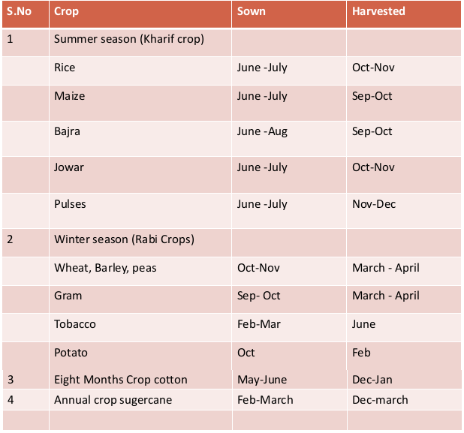Pollutionofundergroundwater.
  + Resultsincolderanddamperclimatecausingoutbreakofdiseaseslikemalaria.

##### TypesofCrops:

1. **Wetcrops**-whichlandsareirrigatedandthancroparecultivation
2. **Drycrops**-whichdonotneedirrigation.
3. **Gardencrops**-whichneedirrigationthroughouttheyear
4. **Summercrop(Kharif)**-whicharesownduringthesouthwestmonsoon&harvestedinautumn.
5. **Wintercrops(rabi)**-whicharesowninautumn&harvestedinspring.
6. **Cashcrop**–whichhastobeencasedinthemarket.Asitcannotbeconsumeddirectlyby thecultivators.

##### Crop

**Seasons:**

* + InnorthIndiathecropseasonisdividedasRabi&Kharif.
  + Rabicropsarecalledaswintercropsandkharifcropsarecalledassummercrops.
  + Kharifcropsrequiredmorewaterthanrabicrops.
  + Rabistartsfrom1stoctandendson31march
  + InTamilNaducropsareclassifiedaswetanddrycrops.

##### Cropsrotation:

Rotationofcropsimpliesthenatureofthecropsowninaparticularfieldischangedyearafteryear.

##### Necessityforrotation

* + - The necessity for irrigation when the same crop is grown again andagain inthe same field, the fertility of land gets reduced as the soil becomes deficient in plantfoods favorable to that particular crop.
    - If different crops were to be raised there would certainly be more balanced fooding andsoil deficient in one particular type of nutrient is allowed to recouped.
    - Crop diseases and insect pests will multiply at an alarming rate, if the same crop is to be grown continuously. Rotation will check the diseases.
    - Aleguminouscrop(suchas gram)ifintroducedinrotationwillincrease nitrogencontentof soil thus increasing its fertility.
    - The deep rooted and shallow rooted crops in rotation draw their food from different depths of soil. The soil will be better utilized.
    - Rotation of crops is beneficial to the farmers as there would be rotation of cash crops, fooderand soil renovating crops.

##### Generalrotationofcropscanbesummarizedas:

* + - 1. Wheat–greatmillet–gram.
      2. Rice–gram
      3. Cotton–wheat–gram.
      4. Cotton–wheat–sugarcane
      5. Cotton–greatmillet–gram.

##### ConsumptiveUseofWater

* + - Considerablepartofwaterappliedforirrigationislostbyevaporation&transpiration.
    - This two processes being difficult to separate are taken as one and called Vapor- transpiration or Consumptive use of water.

##### Duty :

**Delta:**

Duty-Areaofthecropirrigated/Volumeofwaterrequired.

* + - Thedepthofwaterrequiredeverytime,generallyvariesdependinguponthetypeof thecrop.
    - Thetotaldepthofwaterrequiredacroptonatureiscalled delta.
    - Cropperiod-thetimefromtheinstantofitssowingtotheinstantofharvesting.
    - BasePeriod-timeb/wthefirstsupplyofwatertothelandandthelastwatering beforeharvesting.

##### Factoraffectingtheduty:

1. **SoilMoisture**
   * Inclayeysoillesswaterisrequiredsinceitsretentivecapacityismore.
   * Pervioussoilitwillbemore.

##### Topography

* + Uniformdistributiondependsontopography.
  + If theareaisslopingthelowerportionwill getmorewaterthan theflatportion, & henceWater requirement is increase.

##### Natureofrainfall

* + If rainfall is high over the crop period water requirement becomes less, otherwise it will bemore.

##### Natureofcropirrigated

* + Drycroprequiredlesswaterwhereaswedcroprequiredmorewater.

1. Methodofcultivation:
   * Ifthefieldsareproperlyplougheditwillhavehighretentivecapacity&thenumber ofwatering are reduced.

##### Seasonof crop

* + Lessirrigationwaterisrequiredforrainyseasoncropandthedutyincreased.
  + Ifthecropgrowninsummer,moreirrigationwaterisrequired&thedutygetsdecreased

##### SystemofIrrigation

* + Inperennialirrigation,continuous supply ofwater is given& hence water table is kept high& percolation losses is minimized
  + Ininundationtypewastageismorebydeeppercolation.

##### CanalCondition

* + Wellmaintainedcanalwillhavemoredutyasthelossesisless.

##### ImprovingDuty

* + 1. Thewaterlossescanbereducedbyhavingtheirrigatedareanearertotheheadof thecanal.
    2. Evaporationlossescanbeminimizedbyusingthewaterasquicklyaspossible.
    3. Waterlossescanbeminimizedbyliningthecanals.
    4. Thecultivatorsshouldbetrainedtousewatereconomicallywithoutwasting.
    5. Thesoilpropertiesshouldbestudiedbyestablishingresearchstationsinvillages.

##### CropPeriodorBasePeriod:

* Thetimeperiodthatelapsesfromtheinstantofitssowingtotheinstantofitsharvesting iscalled the **crop period**.
* The time between the first watering of a crop at the time of its sowing to its last watering before harvesting is called the **base period**.

##### DutyandDeltaofaCropDelta:

The total quantity of water required by the crop for its full growth may be expressed in hectare-meter or simply as depth to which water would stand on the irrigated area if the total quantity supplied were to stand above the surface without percolation or evaporation. This total depth of water is called delta (∆).

**Problem** –1**:**If rice requires about 10 cm depth of water at an averageinterval of about 10 days,and the crop period for rice is 120 days, find out the delta for rice.

#### Solution:

No.ofwateringrequired=120/10= 12

Totaldepthofwaterrequiredin120days=10×12=120cm

∆forrice=120 cm

**Problem** –2**:** If wheat requires about 7.5 cm of water after every 28 days, and the base period forwheat is 140 days, find out the value of delta for wheat.

#### Solution:

No.ofwateringrequired=140/28=5

Totaldepthofwaterrequiredin140days=7.5×5=37.5cm

∆forwheat=37.5cm

##### Duty:

* + It may be definedas the number of hectares of landirrigated for full growth of a given cropby supply of 1 m3/s of water continuously during the entire base ofthat crop.
  + Simplywecansaythat,thearea(inhectares)oflandcanbeirrigatedforacropperiod,B (indays) using one cubic meter of water.

##### Factorsonwhichdutydepends:

* + 1. Typeofcrop
    2. Climateandseason
    3. Usefulrainfall
    4. Typeofsoil
    5. Efficiencyofcultivationmethod

##### ImportanceofDuty

* + Ithelpsusindesigninganefficientcanalirrigationsystem.
  + Knowing the total available water at the head of a main canal, and the overall duty for all thecrops required to be irrigated in different seasons of the year, the area which can be irrigatedcan be worked out.
  + *Inversely, if we know the crops area required to be irrigated and their duties, we can work out the discharge required for designing the channel.*

##### Measuresforimprovingdutyofwater:

Thedutyofcanalwatercancertainlybeimprovedbyeffectingeconomyinthe useofwater by resorting to the following precautions and practices:

##### ProperPloughing:

Ploughingshouldbedoneproperlyanddeeplysothatthemoistureretainingcapacityofsoilis increased.

##### Methodsofsupplyingwater:

The method of supplying water to the agriculture land should be decided according to thefield and soil conditions. For example,

* + FurrowmethodForcropssownionrows
  + ContourmethodForhillyareas
  + BasinFororchards
  + FloodingForplainlands

##### CanalLining:

Itisprovidedtoreducepercolationlossandevaporationlossduetohighvelocity.

##### MinimumidlelengthofirrigationCanals:

Thecanalshouldbenearesttothecommand areasothatidlelengthofthecanalisminimum and hence reduced transmission losses.

##### Qualityofwater:

Good quality of water should be used for irrigation. Pollution en route the canal should beavoided.

##### Croprotation:

The principle of crop rotation should be adopted to increase the moisture retaining capacity and fertility of the soil.

##### Consumptive use of cropsDefinition:

* Itisthequantityofwaterusedbythevegetationgrowthofagivenarea.
* It is the amount ofwater requiredbya cropfor its vegetated growth toevapotranspiration and building of plant tissues plus evaporation from soils and intercepted precipitation.
* It is expressed in terms of depth of water. Consumptive use varies with temperature, humidity, wind speed, topography, sunlight hours, method of irrigation, moisture availability.

Mathematically,

ConsumptiveUse=Evapotranspiration=Evaporation+transpiration

* Itisexpressedintermsofdepthofwater. **FactorsAffectingtheConsumptiveUseofWater** Consumptive use of water varies with:
  1. Evaporationwhichdependsonhumidity
  2. MeanMonthlytemperature
  3. Growingseasonofcropsandcroppingpattern
  4. Monthlyprecipitationinarea
  5. Windvelocityinlocality
  6. Soilandtopography
  7. Irrigationpracticesandmethodofirrigation
  8. Sunlighthours

##### TypesofConsumptiveWaterUse

Followingarethetypesofconsumptive use,

1. Optimum ConsumptiveUse
2. PotentialConsumptiveUse
3. SeasonalConsumptive Use

##### OptimumConsumptiveUse:

Itistheconsumptiveusewhichproducesamaximumcropyield.

##### PotentialConsumptiveUse:

If sufficient moisture is always available to completely meet the needs of vegetation fullycovering the entire area then resulting evapotranspiration is known as Potential Consumptive Use.

###### SeasonalConsumptiveUse:

Thetotalamountofwaterusedintheevapo-transpirationbyacroppedareaduringtheentiregrowing season.

##### CropWaterRequirements Soil moisture

**Classesandavailabilityofsoilwater**

Waterpresentinthesoilmaybetoclassifiedunderthreeheads

* 1. Hygroscopicwater
  2. Capillarywater
  3. Gravitationalwater

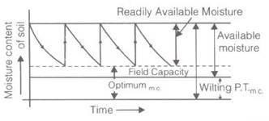Water attached to soil particles through loose chemical bonds is termed hygroscopic water.This water can be removed by heat only. But the plant roots can use a very small fraction of this soil moisture under drought conditions.

**Capillarywater**

The capillarywaterisheldwithinsoilporesduetothesurfacetensionforces (againstgravity) which act at the liquid-vapour (or water-air) interface.

**Gravitationalwater**

Gravity water is that water which drains away under the influence of gravity. Soon after irrigation (or rainfall), this water remains in the soil and saturates the soil, thus, preventing circulation of air in the void spaces.

1. Available moisture for the plant

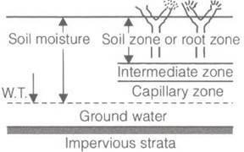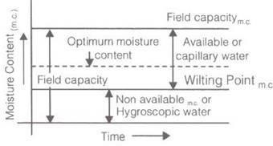

1. Readilyavailablemoisturefortheplant=FC-Mo Here FC= field capacity

φ=wiltingpointorwiltingcoefficientbelowplantcan’tsurvive.

Mo=Readilyavailablemoisturecontent

1. FrequencyofIrrigation
2. 

where,weightofwaterstoredinsoilofunitareaWeight of some soil of unit area

dw=depthofwaterstoredinrootzone.

1. dry unit wt. of soil
2. Available moisture depth to plant
3. Readily availablemoisture depthtoplant
4. where, G= specific gravity and n = porosity

##### Dutyanddelta Duty:

* + The dutyofwateristhe relationshipbetween the volume ofwater andthe area ofthe crop it[matures.](http://matures.it/)
  + [It](http://matures.it/)isdefinedastheareairrigatedpercumecofdischargerunningforbaseperiodB.
  + ThedutyisgenerallyrepresentbyD.

##### Delta:

* + Itisthe totaldepthofwaterrequiredbyacropduringtheentire baseperiodand isrepresented by the symbol Δ.

##### Relationbetweendutyanddelta



Where,

* + - Δ**=**Deltainmeter
    - D=DutyinHa/cumec
    - B=Base periodindays

Also 

Where,

* + - Δ**=**Deltainmeter
    - B=Base periodindays
    - D=Dutyinacre/cures

##### IrrigationRequirementsofcrops

1. **ConsumptiveIrrigationRequirement(CIR)**

CIR=Cu-Peff

Where,Cu=totalconsumptiveuserequirement Peff= Effective rainfall.

##### NetIrrigationRequirement(NIR)

NIR=CIR+Leachingrequirement

##### Fieldirrigationrequirement(FIR)



1. **Grossirrigation requirement, (GIR)**



##### MethodsofDeterminationofEvapotranspiration

Tomeasureorestimationtheconsumptiveusetherearethreemainmethods:

* 1. DirectMethods/FieldMethods
  2. EmpiricalMethods
  3. Panevaporationmethod

##### DirectMethods:

Inthismethodfieldobservationsaremadeandphysicalmodelisusedforthispurpose.This includes,

* 1. VapourTransferMethod/[SoilMoistureStudies](https://www.aboutcivil.org/to-determine-moisture-content-of-soil.html)
  2. FieldPlotMethod
  3. TanksandLysimeter
  4. IntegrationMethod/SummationMethod
  5. IrrigationMethod
  6. InflowOutflowMethod

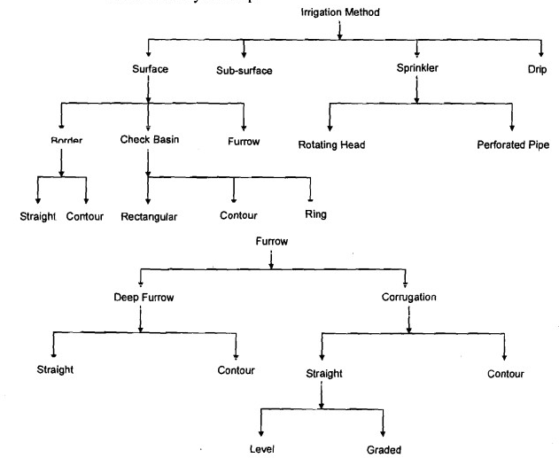

##### SURFACEIRRIGATION:

* Surface irrigation is defined as the group of application techniques where water isappliedand distributed over the soil surface by gravity.
* It is by farthe most common form ofirrigation throughout the world and has been practicedin many areas virtually unchanged for thousands of years.

##### Surfaceirrigation:

Therearefourvariationsunderthismethodviz.

1. Flooding,
2. Bedorbordermethod(Sarasandflatbeds
3. Basinmethod(ringandbasin)and
4. Furrowmethod(ridesandfurrows,broadridgesorraisedbeds)

##### Flooding:

* + Itconsistofopeningawaterchannelinaplotorfieldsothatwatercanflowfreelyin alldirections and cover the surface of the land in a continuous sheet.
  + It is the most inefficient method of irrigation as only about 20 percent of the water isactually used by plants. The rest being lost as a runoff, seepage and evaporation.
  + Water distribution is very uneven and crop growth is not uniform. It is suitable for uneven land where the cost of leveling is high and where a cheap and abundant supply of water is available.
  + It is unsuitable for crops that are sensitive to water logging the method suitable where broadcast crops, particularly pastures, alfalfa, peas and small grains are produced.

##### Adaptations:

* + 1. Anabundantsupplyofwater
    2. Closegrowingcrops
    3. Soilsthatdonoterodeeasily
    4. Soilsthatispermeable
    5. Irregulartopography
    6. Areaswherewaterischeap.

###### Advantages:

1. Canbeusedonshallowsoils
2. Canbeemployedwhereexpenseoflevelingis great
3. Installationandoperationcostsarelow
4. Systemisnotdamagedbylivestockanddoesnotinterferewithuseoffarmimplements.

###### Disadvantages:

1. Excessivelossofwaterbyrunofand deeppercolation
2. Excessivesoilerosiononstepland.
3. FertilizerandFYMareerodedfromthesoil.

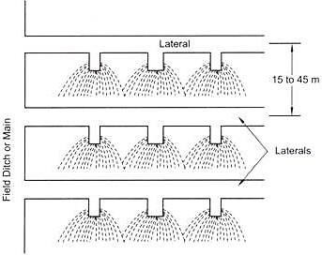

##### Bedorbordermethod(SaraandFlatbedsorcheckbasin):

* + In this method the field is leveled and divided into small beds surrounded by bunds of 15to 30 cm high. Small irrigation channels are provided between two adjacent rows of beds.
  + Thelengthofthebedvariesfrom30metersforloamysoilsto90metersforclayeysoils.
  + Thewidthissoadjustedastopermitthewatertoflowevenlyandwetthelanduniformly.
  + For high value crops, the beds may be still smaller especially where water is costly and not very abundant.
  + This method is adaptable to most soil textures except sandy soils and is suitable for high value crops. It requires leveled land.
  + It is more efficient in the use of water and ensures its uniform application. It is suitable for crops plant in lines or sown by broadcast. Through the initial cost is high requires less labourand low maintenance cost.
  + This mayalso be called a sort of sara method followedlocally inMaharashtra but the saras to be formed in this method are much longer than broader.

**TypesofBorderIrrigation**

Twotypesofbordersareformed:

* + StraightBorder
  + These border are formed along the general slope of the field. These are preferred when fieldscan be levelled or be given a gentle slope economically.

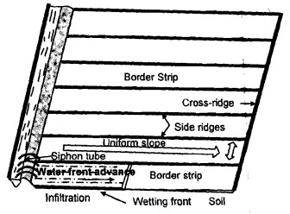•

##### ContourBorder

* + Theseareformedacrossthegeneralslopeofthefieldandarepreferredwhenland slopeexceeds the safe limits.
  + As fields are undulating and require a lot of earth work to level, economical levelling is not possible. Design criteria for both are not different.

##### Adaptations:

* + 1. Alargesupplyofwater
    2. MostsoiltexturesincludingsandyLoam,loamsandclays
    3. Soilatleast90cm deep
    4. Suitableforclosegrowingcrops.

##### Advantages:

1. Fairlylargesupplyofwaterisneeded.
2. Landmustbeleveled
3. Suitedonlytosoilsthatdonotreadilydisperse.
4. Drainagemustbeprovided

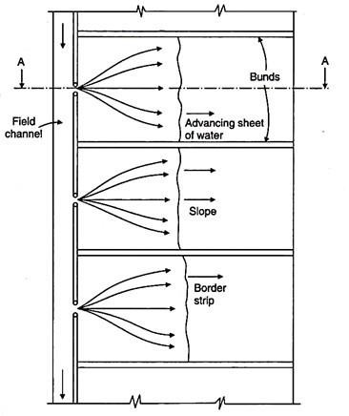

##### Basinirrigation:

* + This method is suitable for orchids and other high value crops where the size of the plot tobe irrigated is very small.
  + The basin may be square, rectangular or circular shape. A variation in this method viz. ring and basin is commonly used for irrigating fruit trees.
  + A small bund of 15 to 22 cm high is formed around the stump of the tree at a distance of about 30 to 60 cm to keep soil dry.
  + The height of the outer bund varies depending upon the depth of water proposed toretain. Basin irrigation also requires leveled land and not suitable for all types of soil. It is also efficient in the use of water but its initial cost is high.
  + There are manyvariations in its use, but all involve dividingthe field intosmaller unit areas so that each has a nearly level surface. Bunds or ridges are constructed around the areas forming basins within which the irrigation water can be controlled. Check basin types may be rectangular, contour and ring basin.

##### Types of Check Basins Based on Size and Shape

The size of check basins may vary from one meters square, used for growing vegetables and other intensive cultivation, to as large as one or two hectares or more, used for growing rice under wet land conditions. While the following points need to be considered :

##### Rectangular

The basins are rectangular in shape when the land can be graded economically into nearlylevel fields.

##### Contour

* + The ridges follow the contours of the land surface andthe contour ridgesare connectedby cross ridges at intervals when there is rolling topography.
  + The vertical interval between contour ridges usually variesfkom 6 to 12 cm in case of upland irrigated crops like wheat and 15 to 30 cm in case of low land irrigated crops like rice.

##### Adaptations:

* + 1. Mostsoiltexture
    2. Highvaluecrops
    3. Smoothtopography.
    4. Highwatervalue/ha

##### Advantages:

1. Varyingsupplyofwater
2. Nowaterlossbyrunoff
3. Rapidirrigationpossible
4. Nolossoffertilizersandorganicmanures
5. Satisfactory

##### Disadvantages:

1. Iflandisnotleveledinitialcostmaybehigh
2. Suitablemainlyfororchids,rice,jute,etc.
3. Exceptrice,notsuitableforsoilsthatdisperseeasilyandreadilyfromacrust.

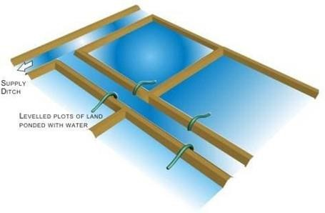

##### FurrowMethod

* + In this method, irrigation water is useful for row crops. Narrow channels are dug at regularintervals.Waterfromthemainsupplyisallowedtoenterthesesmallchannelsor furrows.
  + Water from the furrows infiltrates into soil and spread laterally to saturate the root zone ofthe crops.
  + Itissuitableforrowcropslikepotatoes,sugarcane,tobacco,maize,groundnut, cotton,jowar, etc.
  + Rowcropssuchaspotatoes,cotton,sugarcane,vegetableetc.canbeirrigatedby furrowmethod. Water is allowed to flow in furrow opened in crop rows.
  + Itissuitableforsloppylandswherethefurrowsaremadealongcontours.Thelength offurrow is determined mostly by soil permeability.
  + It varies from 3 to 6 meters. In sandy and clay loams, the length is shorter than in clay and clay loams. Water does not come in contact with the plant stems.
  + There is a great economy in use of water. Some times, even in furrow irrigation the field is divided into beds having alternate rides and furrows. On slopes of 1 to 3 percent, furrow irrigation with straight furrows is quite successful.
  + But on steeper slopes contour furrows, not only check erosion but ensure uniform water penetration.

Irrigationfurrowsmaybeclassifiedintotwogeneraltypesbasedontheiralignment.Theyare:

1. straightfurrows,and
2. contourfurrows.

##### StraightFurrows

* + They are best suited to sites where the land slope does not exceed 0.75 per cent. In areas of intense rainfall, however, the furrow grade should not exceed 0.5 per cent so as to minimise the erosion hazard.
  + The range in furrow slopes for efficient irrigation in different soil types are the same as thoserecommended for borders.

##### ContourFurrows

* + Contour furrows carrywater across a slopping fieldrather than the slope. Contour furrows are curved to fitthe topography of the land.
  + Contour furrow methodcan be successfully used in nearlyall irrigable soils. The limitations of straight furrow are overcome by contouring to include slopping lands. Light soils can be irrigated successfully across slopes up to 5 per cent.

##### Adaptations:

* + 1. Mediumandfinetexturedsoils.
    2. Variablewatersupply
    3. Farmswithonlysmallamountofequipment.

##### Advantages:

1. Highwaterefficiency
2. Canbeusedinanyrow crop
3. Relativelyeasyinstall
4. Notexpensivetomaintain
5. Adaptedtomostsoils.

##### Disadvantages:

* 1. Requirementofskilledlabourismore
  2. Ahazardtooperationofmachinery
  3. Drainagemustbeprovided.

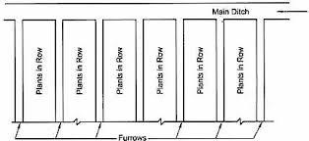

##### Contourfarming

* + Contour farminginvolves ploughing,planting andweedingalongthe contour,i.e,across theslope rather than up and down.
  + Contourlinesarelinesthatrunacrossa(hill)slopesuchthatthelinestaysatthe sameheight and does not run uphill or downhill.
  + As contour lines travel across a hillside, they will be close together on the steeper partsofthe hill and further apart on the gentle parts of the slope.
  + Experimentsshow thatcontour farmingalone canreduce soilerosionbyasmuchas50% onmoderate slopes.
  + However,forslopessteeperthan10%,othermeasuresshouldbecombinedwith contourfarming to enhance its effectiveness.

##### Benefits :

* + 1. Contouringcanreducesoilerosionbyasmuchas50%fromupanddownhill farming
    2. Byreducingsedimentandrunoffandincreasingwaterinfiltration
    3. Contouringpromotesbetterwaterquality
    4. Itgives10-15%additionalyield.

##### CriteriaforSurfaceIrrigationMethodSelection

1. Adaptedtomostsoils.

##### Disadvantages:

1. Requirementofskilledlabourismore
2. Ahazardtooperationofmachinery
3. Drainagemustbeprovided.



##### Contourfarming

* + Contour farminginvolves ploughing,planting andweedingalongthe contour,i.e,across theslope rather than up and down.
  + Contourlinesarelinesthatrunacrossa(hill)slopesuchthatthelinestaysatthe sameheight and does not run uphill or downhill.
  + As contour lines travel across a hillside, they will be close together on the steeper partsofthe hill and further apart on the gentle parts of the slope.
  + Experimentsshow thatcontour farmingalone canreduce soilerosionbyasmuchas50% onmoderate slopes.
  + However,forslopessteeperthan10%,othermeasuresshouldbecombinedwith contourfarming to enhance its effectiveness.

##### Benefits :

* + 1. Contouringcanreducesoilerosionbyasmuchas50%fromupanddownhill farming
    2. Byreducingsedimentandrunoffandincreasingwaterinfiltration
    3. Contouringpromotesbetterwaterquality
    4. Itgives10-15%additionalyield.

##### CriteriaforSurfaceIrrigationMethodSelection

* + The deciding factors for the suitability of any surface irrigation method arenatural conditions (slope, soil type), type of crop, required depth of application, level of technology,previous experiences with irrigation, required labour input.
  + Moreover the irrigation system for a field must be compatible with the existing farming operations, such as land preparation, cultivation, and harvesting practices.
  + The following outline lists a number of factors of the environment which will have abearingon the evaluation of irrigation system alternates and the selection of a particular system.
  + Not all points will be equally significant in each case, but the outline can serve as a useful checklist to prevent overlooking important factors.

##### PhysicalFactors

* + Cropsandculturalpracticesareofprimeimportancewhileselectinganirrigationsystem.
  + Hence, proper knowledge of agronomic practices and irrigation intervals is necessary for proper use of irrigation water and to increase water use efficiency.
  + Thefollowingphysicalfactorsneedtobegivendueconsideration.

##### CropParameters

* + Toleranceofthecroptosoilsalinityduringdevelopmentandmaturation.
  + Magnitudeandtemporaldistributionofwaternecessaryformaximumproduction.
  + Economicvalueofcrop.

##### SoilsParameters

* + Texture and structure;infiltration rate and erosion potential;salinity and internal drainage, bearing strength.
  + Sandy soils have a low water storage capacity and a high infiltration rate. Under these circumstances, sprinkler or drip irrigation are more suitable than surface irrigation.Clay soils with low infiltration rates are ideally suited to surface irrigation.
  + High intake characteristicrequire higher flow rate to achieve the same uniformity and efficiency.
  + Crustingofsoilanditseffectsoninfiltration
  + Reclamationandsaltleaching-basinirrigation
  + Spatialvariability
  + Locationandrelativeelevationofwatersource–waterdiversion,pumping
  + Acreageineachfield
  + Locationofroads,naturalgaslines,electricitylines,waterlinesandotherobstructions.
  + Shapeoffield–nonrectangularshapesaremoredifficulttodesignfor
  + Fieldslope–steepness&regularity
  + Furrow&borders2-6%maximum

##### ClimateandWeatherConditions

* + Underverywindyconditions,driporsurfaceirrigationmethodsarepreferred.
  + Scalding (the disruption of oxygen-carbon dioxide exchange between the atmosphere andthe root)& the effect of water temperature on the crop at different stages of growth - risk in basin irrigation.
  + Irrigation with cold water early in the spring can delay growth, whereas in the hot periods of the summer, it can cool the environment— both of which can be beneficial or detrimental in somecases.

##### WaterSupply

Thefollowingparametersareimportant:

1. Sourceanddeliveryschedule
2. Waterquantityavailableanditsreliability
3. Waterquality
4. Watertableincaseofgroundwatersource.
5. AvailabilityandReliabilityofElectricity
6. Availabilityandreliabilityofenergyforpumpingofwaterisofmuchimportance.

##### EconomicConsiderations

Thefollowingpointsneedtobeconsideredwhileselectingirrigationalternatives.

* 1. Capitalinvestmentrequiredandrecurringcost.
  2. Creditavailabilityandinterestrate.
  3. Lifeofirrigationsystem,efficiencyandcosteconomics.

##### SocialConsiderations

* + Theeducationandskillofcommonfarmersandlaboursavailable for handlingtheirrigation system
  + Socialunderstandingofhandlingofcooperativeactivitiesandsharingofwaterresources
  + Legal and political considerations, local cooperation and support, availability and skill of labour and level of automatic control

##### SuitabilityandLimitationsofSurfaceIrrigationMethods

* + Some form of surface irrigation is adaptable to almost any vegetable crop. Basin andborder strip irrigation have been successfully used on a wide variety of crops.
  + Furrow irrigationis lesswelladaptedtofieldcropsifcultural practicesrequire travelacross the furrows. However, it is widely used in vegetables like potato.
  + Basin and border strip irrigations flood the soil surface, and will cause some soils to form a crust, which may inhibit the sprouting of seeds.
  + Surface irrigation systems perform better when soils are uniform, since the soil controlsthe intake of water. For basin irrigation, basin size should be appropriate for soil texture and infiltration rate.
  + Basin lengths should be limited to 100 m on very coarse textured soils, but may reach 400 mon other soils. Furrow irrigation is possible with all types of soils, but extremely high or lowintake rate soils require excessive labor or capital cost adjustments that are seldom economical.
  + A major cost in surface irrigation is that of land grading or leveling. The cost is directly related tothe volume ofearththat must be moved, the area to be finished, and the length andsize of farm canals.

##### MICROIRRIGATIONMETHOD

* + Micro irrigation methods are precision irrigation methods of irrigation with very high irrigation water efficiency.
  + In many parts of the country there is decline of irrigation water and conventional methods are having low water use efficiency.
  + Tosurmountthe problem,micro irrigationmethodsh8srecently been introduced inIndian agriculture.
  + These methods save a substantial amount of water and helps increasing crop productivity particularly valuable cash crops like vegetables.
  + The research results have confirmed a substantial saving of water ranging between 40 to80% and there are reports of two times yield increase for different crops crops by using micro irrigation.

##### Twomainmicroirrigationsystemsare:

**AdvantagesofMicroIrrigation**

1. Watersaving,possibilityof usingsalinewater.
2. Efficientandeconomicuseoffertilizers.
3. Easyinstallation,flexibilityinoperation.
4. Suitabletoalltypesoflandterrainalsosuitabletowastelands.
5. Enhancedplantgrowthandyieldanduniformandbetterqualityofproduce.
6. Lessweedgrowth.
7. Laboursaving.
8. Nosoilerosion,saveslandasnobunds,etc.arerequired.
9. Minimumdiseasesandpestinfestation.

##### SPRINKLERIRRIGATION

* + In sprinkler irrigation, water is delivered through a pressurized pipe network to sprinklers nozzles or jets which spray the water into the air.
  + To fall to the soil in an artificial "rain". The basic components ofany sprinkler systems are : a water source. a pump to pressurize the water.
  + A pipe network to distribute the water throughout the field. sprinklersto spray the water over the ground, and valves to control the flow of water.
  + The sprinklerswhenproperlyspacedgive arelativelyuniformapplication of water over the irrigated area.

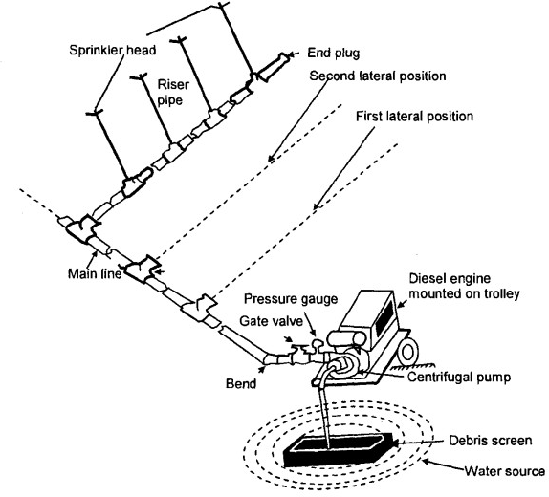

##### Components of

**Sprinklerirrigation System**

* + Sprinkler systems are usually fthere are some exceptions) designed to apply water at a lowerrate than the soil infiltration rate so that the amount of water infiltrated at any point depends upon the application rate and time of application but notthe soil infiltration rate.

##### GeneralClassificationofSprinklerSystems

Sprinklersystems are classified into the followingtwo majortypes on the basis ofthe arrangement for spraying irrigation water.

1. Rotatingheadorrevolvingsprinklersystem.
2. Perforatedpipesystem.

##### ComponentsofSprinklerIrrigationSystem

Sprinklersystemusuallyconsistsofthefollowingcomponents :

1. Apumpunit
2. Tubings-main/sub-mainsandlaterals
3. Couplers
4. Sprinkerhead
5. Otheraccessoriessuchasvalves,bends,plugsandrisers.

##### SuitabilityandLimitations

With regards to crops, soils, and topography nearly all crops can be irrigated with some type of sprinkler system though the characteristics of the crop especially the height, must be considered in system selection.

Sprinklers are sometimes used to germinate seed and establish ground cover for crops like lettuce alfalfa and sod.

The light frequent applications that are desirable for this purpose are easily achieved with some sprinkler systems.

Sprinklers are applicable to soils that are too shallow to permit surface shaping or too variable for efficient surface irrigation.

In general, sprinklers can be used on any topography that can be formed. Land leveling is not normally required.

With regards to labour and energy considerations, it has been observed that labour requirements vary depending on the degree of automation and mechanization of the equipment used.

Hand-movesystemsrequiretheleastdegreeofskill,butthegreatestamountoflabor.

##### AdvantagesofSprinklerIrrigation

Thefollowingsaretheadvantagesofsprinklerirrigation:

1. Eliminationofthechannelsforconveyance,thereforenoconveyanceloss.
2. Suitable to all types of soil except heavy clay, suitable for irrigating crops where the plant population per unit area is very high. It is most suitable for oil seeds and other cereal and vegetable crops.
3. Water saving, closer control of water application convenient for giving light and frequentirrigation and higher water application efficiency.
4. Increaseinyield.
5. Mobilityofsystem.
6. May also be used for undulating area, saves land as no bunds etc. are required, areas located at a higher elevation than the source can be irrigated.
7. Influencesgreaterconducivemicro-climate.
8. Possibilityofusingsolublefertilizersandchemicals.
9. Lessproblemofcloggingofsprinklernozzlesduetosedimentladenwater

##### CapacityofSprinklerSystem

Thecapacityofthesprinklersystemmaybecalculatedbytheformula:



Where,

Q=Dischargecapacityofthepump,liter/second, A = Area to be irrigated, hectares,

d=Netdepthofwaterapplication, cm,

F=Numberofdaysallowedforthecompletionof one irrigation,

H=Numberofactualoperationhoursperday,and E = WaterApplication Efficiency in %

##### DRIPIRFUGATION

* Drip irrigation, also known as trickle irrigation or microirrigation is an irrigation method which minimizes the use of water and fertilizer by allowing water to drip slowly to theroots of plants, either onto the soil surface or directly onto the root zone, through a network of valves, pipes, tubing, and emitters.
* Itis becoming popular for row crop irrigation. This system is used in place of water scarcity as it minimizes conventional losses such as deep percolation, evaporation and run-off or recycled water is used for irrigation.
* Small diameter plastic pipes fitted with emitters or drippers at selected spacing to deliver therequired quantity of water are used. Drip irrigation may also use devices called micro- spray heads, which spray water in a small area, instead of dripping emitters.
* Subsurface dripirrigation (SDI)usespermanentlyor temporarily burieddripper line or drip tape located at or below the plant roots.
* Pumpand valvesmaybemanuallyorautomaticallyoperated by acontrollerDrip irrigation

is the slow, frequent application of water to the soil though emitters placed along a water delivery line.

* The term drip irrigation is general, and includes several more specific methods. Drip irrigationapplies the waterthroughsmallemitterstothesoilsurface,usuallyat or nearthe plant to be irrigated.
* Subsurface irrigation is the application of water below thesoil surface. Emitterdischargeratesfordripandsubsurfaceirrigationaregenerallylessthan12litersperhour.

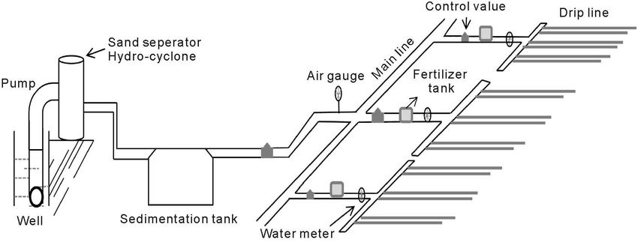

##### ComponentsofDripIrrigationSystem(ListedinOrderfromWaterSource)

* 1. Pumporpressurisedwatersource.
  2. WaterFilter(s)-FiltrationSystems:SandSeparator,Cyclone,ScreenFilter,Media Filters.
  3. FertigationSystems(Venturiinjector).
  4. BackwashController.
  5. MainLine(largerdiameterPipeandPipeFittings).
  6. Hand-operated,electronic,orhydraulicContvlValvesandSafetyValves.
  7. Smallerdiameterpolytube(oftenreferredtoas"laterals").
  8. PolyfittingsandAccessories(tomakeconnections).
  9. EmittingDevicesatplants(Example:EmitterorDrippers,microsprayheads,inline drippers, trickle rings).

##### Suitabi1ity:andLimitation

1. Fromstandpoint ofcrops,soil,and topography, drip irrigationisbestsuitedfor tree,vine,and row crops. A lot of research work has been conducted to establish the suitability of drip irrigation

fordifferentvegetablecrops.Dripirrigationhasbeenfoundsuitablebothforfieldvegetable crops and also under covered cultivation practices.

1. With respect to water quantity and quality, drip irrigation uses a slower rate of water applicationover a longer period of time than other irrigation methods. The most economical design would have

waterflowingintothe farmarea throughoutmostofthe day, everyday, duringpeakuse periods. If water is not available on a continuous basis, on-farm water storage may be necessary.

1. Though a form of pressurized irrigation, drip is a low pressure, low flow rate method. These conditions require small flow channel openings in the emission devices, which are prone to plugging.
2. High efficiencies are USP of drip irrigation system. Properly designed and maintained drip systems are capable of high efficiencies. Designefficiencies should be on the order of 90 to 95%.
3. Labour and energy considerations are very important consideration in drip irrigation system. Due to their low flow characteristics, drip irrigation systems usually have few sub-units, and are designed for long irrigation times.
4. Drip irrigation systems generally use less energy than other forms of pressurized irrigation systems. The emission devices usually operate at pressures ranging from 5 to 25 PSI. Additional pressure is required to compensate for pressure losses through the control head (filters and control valves) and the pipe network.
5. Economicfactorsneedspecialattentionincasedripirrigationsystemasinitialcost andoperational cost is reasonably high. Drip systems costs can vary greatly. Depending on crop (plant. and therefore. emitter and hose spacings) and type of hose employed (permanent or "disposable" thin-walled tubing).

##### Advantages

Theadvantagesofdripirrigationare:

* 1. Minimised fertilizerlnutrient loss due to localized application and reduced leaching, allowssafe use of recycled water.
  2. High water distribution efficiency. Moisture within the root zone can be maintained at fieldcapacity.
  3. Levelingofthefieldnotnecessary.Soiltypeplayslessimportantroleinfrequencyof irrigation, minimised soil erosion.
  4. Highlyuniformdistributionofwater,i.e.controlledbyoutputofeachnozzle.
  5. Lowerlabourcost.
  6. Earlymaturityandgoodharvest.
  7. Foliageremainsdrythusreducingtheriskofdisease.

|  |  |  |
| --- | --- | --- |
| **Performance Indicator** | **ConventionalIrrigationMethods** | **DripIrrigation** |
| Watersaving | Wastelotofwater.Lossesoccurdueto percolation, runoff and evaporation | 40-70% of water can be saved over conventionalirrigationmethods.Runoff and deep percolation losses are nil or |

|  |  |  |
| --- | --- | --- |
|  |  | negligible. |
| Wateruseefficiency | 30-50%,becauselossesareveryhigh | 80-95% |
| Savingin labour | Labour engaged per irrigation is higher than drip | Labourrequiredonlyforoperationand periodic maintenance of the system |
| Weed infestation | Weedinfestationisveryhigh | Lesswettingof soil,weedinfestationis very less or almost nil. |
| Useofsaline water | Concentration of salts increases and adversely affects the plant growth. Saline water cannot be used forirrigation | Frequent irrigation keeps the salt concentration within root zone below harmful level |
| Diseases and pestproblems | High | Relatively less because of less atmospheric humidity |
| Suitabilityin differentsoil Type | Deep percolation is more in light soil andwithlimitedsoildepths.Runoffloss is more in heavy soils | Suitable for allsoiltypes as flow rate can be controlled |
| Watercontrol | Inadequate | Verypreciseandeasy |
| Efficiencyof fertilizer use | Efficiencyislowbecauseofheavy losses due to leaching and runoff | Veryhighdueto reducedlossofnutrients through leaching and runoff water |
| Soilerosion | Soil erosion is high because of large stream sizes used for irrigation. | Partial wetting of soil surface and slow applicationrates eliminate anypossibility of soil erosion |
| Increaseincrop yield | Non-uniformityinavailablemoisture reducing the crop yield | Frequent watering eliminates moisture stress and yield can be increased up to15- 150% as compared to conventional methods of irrigation. |

ExtentofWaterSavingandIncreaseinYieldwithDripIrrigationSystems

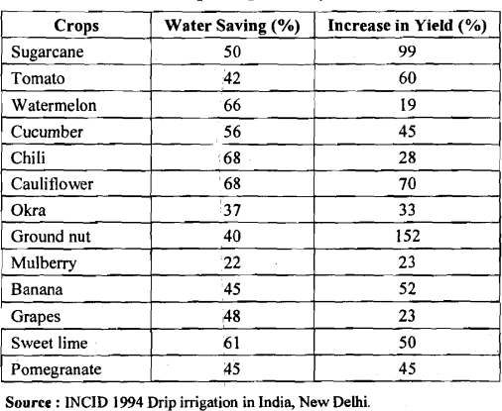

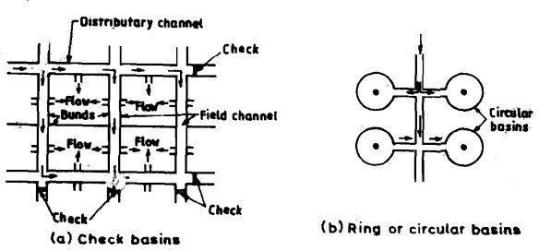**Check Basin Irrigation** : In this irrigation system, water is applied to a completely level or dead level area enclosed by dikes or boarders.

**Furrow Irrigation** : Furrows are sloping channels formed in the soil. Infiltration occurs laterally and vertically through the wetted perimeter of the furrow and plants get water in its root zone.

**Sprinkler Irrigation** : In this system of irrigation, water is delivered through a pressurised pipe network to sprinklers nozzle or jets which spray water into the air.

**Drip Irrigation** : It minimisesthe use of water and fertilizer by allowing water to drip slowly to the roots of plants.

**Fertigation** : It is the process of application of water soluble solid fertilizer or liquid fertilizer through drip irrigation system.

##### Waterdistribution system

Irrigation water inay be applied to crops either by floodingthe field. by applyingwater beneath the soil surface, by spraying it under pressure. or by applying it in drops. Selection of the suitable method, from among these methods, depends on topography. soil condition, land preparation, type of crop and its value. available water supply and other factors

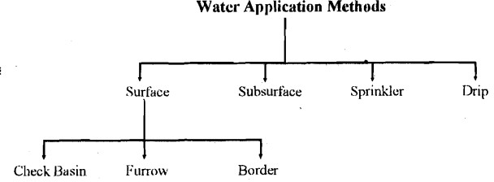

##### CHECKBASINIRRIGATION

Check basin irrigation or simply basin irrigation is the simplest available mode of irrigation and commonly practised in India end other countries. The principle underlying this system involves dividing tile field or fanil into smaller unit areas such that each has a nearly level surface.

##### Methods toApplyIrrigationWatertocheckBasins

There are two methods to supply imgation water to check basins, namely, direct method, and cascade inetliod.

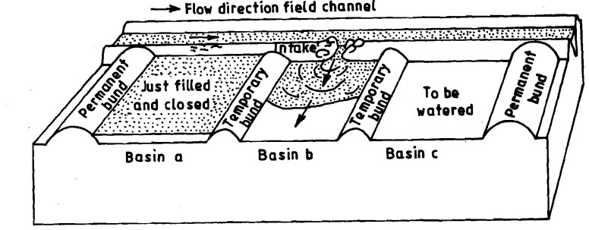In the direct method. irrigation water is led dircctly from thc field channel into the basins through siphons. or bund breaks, basin A is irrigated first and then basin B and so on. This method can bc used for most crop types. and is also suitable for nlost type of soil.

DirectMethod

The other method. namely, the cascade method is suitable for slopingland where terraces are used. In this method, the irrigation water is supplied to the highest terrace, and then allowed to flow to a lower terrace and so on. In Figure water is supplied to tlie tcrrace A1 until tlie lowest terrace A3 is fillcd. Tlie supply to A1 is tlien closed and irrigation water is diverted to terrace B1 until B I, B2 and B3 are filled, and so on.

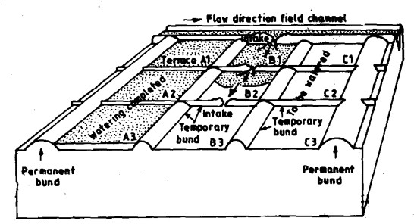

CascadeMethod

* About5%ofsandbyvolumeisaddedtothedugupsoilandmixedwell.
* The pit is then filled back with the mixture and while filling up every 15 cm layer is well compacted, so that the soil in the pit retains the original bulk density as that ofsurrounding soil.
* Cropissownnormallyandisallowedtogrowasusualwiththerestofthefield.
* As and when the plants in the mini-plot show wilting symptoms it is taken as a warning of impending water need and cropped field is irrigated.

##### Plantpopulation

* Increaseinplantpopulationby1.5to2.0timesthatofoptimum
* This happens because when more plants are there per unit area, the available waterwithinthat zone is depleted rapidly as compared to other area
* Thisresult in drooping orwilting of plantsearlier, which can betaken as an indicationof water deficits and accordingly irrigations are scheduled to crops.

##### Rateofgrowth

* Growth of a plantis dependenton turgor, whichin turn is dependenton afavourable soilwater balance.
* So fluctuations in the water balance are reflected by parallel fluctuations in the growth rateof expanding organs.
* Stem elongation is markedly reduced when the available soil moisture level approaches thecritical level, but accelerates again after irrigation.

##### Canopy temperatureIndicatorplants

* In wheat, scheduling irrigations on the basis of wilting symptoms in maize and sunflowergave the highest grain yields.

##### Criticalgrowthstages

* The cropplants intheir life cycle pass through various phases ofgrowth,some ofwhich arecritical for water supply.
* Themostcriticalstageofcropgrowthistheoneatwhichahighdegreeofwater stresswould cause maximum loss in yield.

##### IrrigationEfficiencies

* Efficiencyistheratioofthewateroutputtothewaterinput,andisusuallyexpressed

aspercentage.

* Inputminusoutputisnothingbutlosses,andhence,ifLossesaremore,outputisless and,therefore, efficiency is less. Hence, efficiency is inversely proportional to the losses.
* Waterislostinirrigationduringvariousprocessesand,therefore,therearedifferentkinds ofirrigation efficiencies, as given below
  + EfficiencyofWater-conveyance
  + EfficiencyofWaterApplication
  + EfficiencyofWaterUse
  + Efficiencyofwaterstorage
  + WaterDistributionEfficiency

##### Efficiency ofWater-conveyance(ηc)

* It is the ratio of the water delivered into the fields from the outlet pointof the channel, to the water entering into the channel at its starting point. It may be represented by ηc. It takes the conveyance or transit losses into consideration.

ηc=(Wf/Wr)X100

Where

* ηc=Waterconveyanceefficiency,
* Wf=WaterdeliveredtotheirrigatedplotatfieldsupplyChannel,
* Wr=Waterdivertedfromthesource(riverorreservoir)

##### EfficiencyofWaterApplication(ηa)

* It is ratio of waterstoredinto the rootzoneof the crop to thequantity of water delivered at thefield (Farm).

ηa=Ws/WfX 100

Where,

* ηa=Waterapplicationefficiency,
* Ws=Waterstoredattherootzoneduringtheirrigation
* Wf=Waterdeliveredtothefarm.

##### EfficiencyofWaterUse(ηu)

* + Itistheratioofthewaterbeneficiallyusedincludingleachingwater,totheQuantity ofwater delivered. It may be represented by ηu

ηu=(Wu/Wd)1X34100

HydraulicsandirrigationEngg

Where,

* + - ηu=Wateruseefficiency,
    - Wu=Beneficialuseofwaterorconsumptive.
    - Wa=Waterdeliveredtothefield.

##### Efficiencyofwaterstorage:(ηs)

* + Theconceptofwaterstorageefficiencygivesaninsighttohowcompletelythe requiredwater has been stored in the root zone during irrigation.

ηs=(Ws/Wn)X100

Where,

* + - ηs=Waterstorageefficiency,
    - Ws=waterstoredintherootzoneduringirrigation.
    - Wn=Waterneedintherootzonepriortoirrigation.

##### WaterDistributionEfficiency (ηd)

Water distribution efficiency evaluates the degree to which water is uniformly distributed throughout the root zone. Uneven distribution has many undesirable results. The more uniformly the water is distributed , the better will be crop response.

ηd=100(1-y/d)

Where,

* + - ηd=Waterdistributionefficiency,
    - y= avg numericaldeviation indepthofwater storedfromavg depthstoredinthe rootzone during irrigation
    - d=Avgdepthofwaterstoredduringirrigation..

##### ConsumptiveuseEfficiency(ηcu)

Itistheratioofconsumptiveuseofwatertothewaterdepletedfromtherootzone.

ηcu=(Wcu/Wd)X100

Where,

* + - ηcu=Consumptiveuseefficiency,
    - Wcu=Nominalconsumptiveuseofwater
    - Wd=Netamountofwaterdepletedfromtherootzonesoil.

****************

### CHAPTER-3

###### FLOWIRRIGATION

**CanalIrrigation**

Irrigation canalisanartificialchannelthatisthe main waterwaythatbringsirrigationwaterfrom a water source to the area to be irrigated.

Theycanbelinedwithconcrete,brick,stoneoraflexiblemembranetopreventseepageand erosion.

**ClassificationofCanalsbasedon DifferentFactors**

A canal is an artificial channel constructed to convey water from rivers, reservoirs, etc. for several purposeslikepowergeneration,navigation, irrigation,etc. Canalsareclassified into differenttypes based on factors such as nature of supply source, functions, type of boundary surface, financial output, discharge capacity and alignment of the canal.

**ClassificationofCanalsbasedonDifferentFactors**

Canalsareclassifiedintodifferenttypesbasedonfactorswhichareasfollows:

1. Basedonthenatureofthesupply source
2. Basedonfunctions
3. Basedonthetypeofboundarysurfacesoil
4. Basedonthefinancialoutput
5. Basedondischarge
6. Basedoncanalalignment

**BasedontheNatureofSupplySource**

1. PermanentCanal
2. InundationCanal
3. **PermanentCanal**

A Permanent canal is a type of canal in which water is available throughout the year. This typeofcanalisgenerallydirectedfromapermanentsourceofsupply waterbodies.Several Permanent hydraulic structures are constructed in this type of canal for water regulationand distribution. A Permanent canal can also be called as a perennial canal.

###### InundationCanal

Inundation canal is a type of canal in which water is available only during the flood periods. These type of canals aretakenoff fromrivers to control the waterlevelinriversduringfloods. Acanalhead regulator is provided to regulate the flow into the canal. Based on Functions of Canal 1. Irrigation canal 2. Power canal 3. Feeder canal 4. Carrier canal 5. Navigation canal

1. Irrigationcanal Acanal alignedalongtheboundariesofcultivatableareasinordertosupplywater for the purpose of agriculture is said to be an irrigation canal.
2. Powercanal Acanal constructedespeciallyforthegenerationofhydraulicpoweristermedas power canal.
3. Feedercanal Asthenamesays,afeedercanalisconstructedtofeedtwo ormoreothercanalsor branch canals.
4. Carrier canal A carrier canal is multi-function canal which serves the purposes of both irrigation canalandfeedercanal.Itmeansthecarriercanalfeedstheothercanalsaswell asprovideswaterfor direct irrigation.
5. Navigationcanal Acanal whichisconstructedespeciallyfornavigational purposesisknownas navigation canal. The water level required in a navigation canal is generally a lot higher to accommodate large ships, vessels, etc

###### BasedonTypeofBoundarySurfaceofCanal

1.Alluvialcanal2.Non-alluvial canal 3.RigidSurfacecanal

1. Alluvial canal Ifthecanalisexcavatedinalluvial soilssuchassilt,sand,gravel,etc.thenitis said to be an alluvial canal.
2. Non-alluvial canal Iftheboundarysurfaceofthecanalisofnon-alluvial soilssuchasloam,clay, rock, etc. then it is said to be a non-alluvial canal.
3. Rigid Surface canal Rigid surface canals also come under non-alluvial canals but here the boundarysurfaceofthecanalislinedartificiallywithahardlayerofliningmaterialsuchascement, concrete, stones, etc.

###### Basedon Discharge

1. Main canal
2. Branch canal
3. Majordistributarycanal
4. Minordistributarycanal
5. Fieldcanal
6. **Maincanal**

The main canal takes off directly from a river or reservoir. It carries water in large amounts to feed thebranchanddistributarycanals.Duetoconveyingof veryhighdischargethroughthemaincanal it is not recommended to do direct irrigation from it**.**

1. **BranchCanal**

Thebranchcanaltakesofffrommaincanalsatregularintervals.Thesecanalssupplywaterto major and minordistributary canals. The discharge of the branch canal isgenerally over 5 m3

/sec.

Inthecaseofbranchcanalsalso,directirrigationisnotrecommendedunlesstheirwatercarrying capacity is very low**.**

1. **MajorDistributaryCanal**

Majordistributarycanaltakesofffromthe branchcanalorin some casesfromthe maincanal. They supply water to minor distributaries and field channels. A canal is said to be major distributary when its discharge lies between 0.25 to 5 m3

/sec.

1. **MinorDistributaryCanal**

Minordistributary canaltakesofffrommajordistributariesand sometimesdirectlyfrombranch canals depending upon the discharge of canals. Their discharge is generally below 0.25 m3

/sec.

Thesecanalssupplywatertothefieldchannels**.**

1. **FieldChannels**

Field channels also known as watercourses are small channels excavated by cultivators in the irrigationfield. These channelsarefedbythedistributarycanalsandbranchcanalsthrough canal outlets**.**

**BasedonCanal Alignment**

1. **Ridgecanal**
2. **Contourcanal**
3. **Side-slopecanal**
4. **RidgeCanal**

A canal aligned along the ridgeline or watershed line of an area is said to be ridge canal or watershed canal. Since it is running at the peak altitude of the area, irrigation on both sides of the canalup toa largerextentof theareaispossible.Thereisno interceptionof naturaldrainson ridge lines hence, no cross drainage works are required for this type of canal**.**

1. **ContourCanal**

A canal aligned roughly parallel to the contours of the area is called a contour canal. This type of canalcanbeseeninhillyregions.Sinceitisparalleltothecontourline,thegroundononesideof the canal is higher and hence irrigation is possible only on the other side of the canal. A contour canal has to pass the drainage and hence cross drainage works are required to be provided.

1. **Side-slopeCanal**

A canal aligned nearly perpendicular to the contour of the area is called a side-slope canal. It is located neither on the ridgeline nor on the valley line but is approximately in between them. It is paralleltothenaturaldrainage lineand hencenocrossdrainage worksare required.Thebed slope of side slope canal is very steep

**Lossesofwaterincanals**

Whenwatercontinuouslyflowthrough acanal,losses takesplacedue to seepage, deeppercolationandevaporation.Theselossesshouldbeproperlyaccountedfor , otherwise lesser quantity of water will be available for agriculture. Water loss in canal can be broadly classified under 3 categories.

* 1. Evaporationloss
  2. Transpirationloss(throughtheweedsandvegetationonthebankofthe channels)
  3. Percolationloss

1. **EvaporationLosses**

Thelossduetoevaporationisgenerallyasmallpercentageoftotallossincanal.It hardly exceeds 1 to 2 % of total water entering into a canal. The evaporation loss depends upon

* 1. Climaticfactor:-Temperature,humidity,windvelocityetc.
  2. Canalfactors:-Watersurfacearea,waterdepths,velocityofflow etc**.**

Maximum losses in there summer season , when temperature is high and wind velocityarealsohigh.Similarlylossesare maximumin canalsdueto widersurface area ,swallower water depths and low velocity. The average evaporation loss per day may vary from 4 mm to 10 mm.

1. **TranspirationLoss**

There is a little loss of water through the plants, vegetation and the weeds on the bankofthecanal.Howeverthiscan becontrolledbykeepingthebankscleanfrom the growth of vegetation and the weeds**.**

1. **Percolationlosses**

Percolationlossconstitutemajorportionoflossinacanal.Theseepagelossesare due to

Permeabilityof thesoilinthebedandonthebanks ofthecanal The depth of the water in the canal

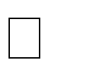

Velocity of the flow Amountofsiltinthewater Temperature of waterAge of the canal

Thedepthofthegroundwater

**Perennialirrigation**

Inperennialsystemofirrigation,constantandcontinuouswatersupplyisensured to thecropinaccordancewiththe crop requirements,throughoutthe cropperiod. In this system of irrigation, water is supplied through storage canal head works and canal distribution system**.**

**CanalAlignment**

**Acanal has to be aligned in such a way that it covers the entire area proposed to be irrigated,with shortestpossiblelengthandatthesametimeitscostincludingcostof drainage works is minimum. Ashorter length of canal ensures less loss of head due**

**to friction and smaller loss of discharge due to seepage and evaporation, so that additional area may be brought under cultivation. Acanal may be aligned as a contourcanal,asideslopecanaloraridgecanalaccordingtothetypeofterrainand culturable area.**

**Irrigationcanalscanbealignedinanyofthe three ways:**

* 1. **WatershedCanal**
  2. **ContourCanal**
  3. **SideslopeCanal**

**WatershedCanal**

**The dividing line between the catchment area of two drains or streams is called watershed. Thus between two major streams, there is the main watershed which dividesthedrainageareasofthetwo.Similarly,betweenanytributary andthemain stream and also between any two tributaries there are subsidiary watersheds, dividing the drainage between the two streams on either side.**

**Forcanalsysteminplainareas,itisoftennecessaryaswellasadvantageoustoalign all channels on the watersheds of the areas, they are designed to irrigate. The canal which is aligned along any natural watershed, is called a watershed canal. In such a canal, water flows by gravity, either side of the canal, directly or through small irrigation channels.**

**Moreover,crossdrainageworksavoidedasthenaturaldrainagewillnevercrossa watershed, because all the drainage flows away from the watershed. Sometimes watershed may have to abandoned in order to bypass localities settled on the watershed.**

**(Alignmentofawatershedcanalalignedalongthewatershed) Contour Canal**

**Theabovearrangementofprovidingthewatershedisnotpossibleinhillyareas.In the hills, the river flows in the valley, while the watershed or the ridge line may be**

**hundredsofmetersaboveit.Itbecomesuneconomicaltotakethecanalontopofsuch ridge. The canal in such cases, is generally aligned parallel to the contours of the area except that the longitudinal slopes required to generate sufficient flow velocity , are given to it.**

**The maximum designed slope that can be provided in the canal without generating excessive velocity, is generally less the available country slope. The difference is accommodatedbyprovidingcanalfallsatsuitable places. Acontourchannelirrigates only on one side because the areas on the other side is higher.**

**Asthedrainageflowisatrightangletothegroundcontours,suchachannelwould definitely have to cross drainage lines. Suitable cross drainage works are then provided.**

**SideslopeCanal**

**Asideslopechannelisthatwhichisalignedatrightanglestothecontours.i.e.along the side slopes. Such a channel is parallel to the natural drainage flow and hence,**

**doesn’tinterceptcrossdrainageandnocrossdrainageworksarerequired.**

**Canallining**

**Canal Linings are provided in canals to resist the flow of water through its bed and sides.Thesecanbeconstructedusingimperviousorfairlyimperviousliningmaterial of sufficient strength such ascompactedearth, cement, concrete, plastics, boulders, bricks etc. The main advantage of canal lining is to protect the water from seepage loss.**

**Advantages of Canal Lining Seepage Reduction PreventionofWaterLogging**

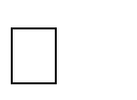

**IncreaseinCommandedArea Increase inChannelCapacity Less Maintenance**



**SafetyAgainstFloods**

1. **SeepageReduction**

The main purpose behind the lining of canal is to reduce the seepage losses. In some soils, the seepage loss of water in unlined canals is about 25 to 50% of total water supplied. The cost of canal lining is high but it is justifiable for its efforts in saving of mostofthewaterfromseepagelosses.Canalliningisnotnecessaryifseepagelosses are very small**.**

1. **PreventionofWaterLogging**

Water logging is caused due to phenomenal rise in water table due to uncontrolled seepage inanunlined canal. Thisseepage effectsthe surroundinggroundwatertable and makes the land unsuitable for irrigation. So, this problem of water logging can

besurelypreventedbyprovidingproperliningtothecanalsides**.**

1. **IncreaseinCommandedArea**

Commanded area is the area which is suitable forirrigation purpose. The water carryingcapacityof linedcanalismuchhigherthantheunlinedcanalandhence more area can be irrigated using lined canals**.**

1. **IncreaseinChannelCapacity**

Canal lining can also increase the channel capacity. The lined canal surface is generallysmoothandallowswatertoflowwithhighvelocitycomparedtounlined channel. Higherthe velocityof flowgreater isthe capacityof channel and hence channel capacity will increase by providing lining.

On the other side with this increase in capacity, channel dimensions can also be reducetomaintainthepreviouscapacityofunlinedcanalwhichsavesthecostofthe project.

1. **LessMaintenance**

Maintenanceoflinedcanaliseasierthanunlinedcanals.Generallythereisaproblem of silting in unlined canal which removal requires huge expenditure but in case of lined canals, because of high velocity of flow, the silt is easily carried away by the water.

In case of unlined canals, there is a chance of growth of vegetation on the canal surface but not in case of lined canals. The vegetation affect the velocity of flow and watercarryingcapacityofchannel.Linedcanalalsopreventsdamageof canalsurface due to rats or insects.

1. **SafetyagainstFloods**

A line canal always withstand against floods while unlined canal may not resists and alsothereischanceofoccurringofbreachwhichdamagesthewholecanalaswellas surroundingareas orfields. Butamongtheall concrete canal liningsaregood against floods or high velocity flows**.**

**TypesofCanalLinings**

Canalliningsareclassifiedintotwomajortypesbasedonthenatureofsurfaceandtheyare:

1. Earthentypelining
2. Hardsurfacelining
3. EarthenTypelining

**EarthenTypelingsare againclassifiedintotwotypes andtheyareasfollows: Compacted Earth Lining**



**Soil Cement Lining CompactedEarthLining**

Compactedearthliningsarepreferredforthecanalswhentheearthisavailablenearthesiteof construction or In-situ. If the earth is not availablenear the site then it becomes costlier to construct compacted earth lining.

Compactionreducessoilporesizesbydisplacingairandwater.Reductioninvoidsizeincreases

thedensity,compressivestrengthandshearstrengthofthesoilandreducespermeability.Thisis accompanied by a reduction in volume and settlement of the surface. Proper compaction is essential to increase the stability and frost resistance (where required) and to decrease erosion and seepage losses**.**

**: CompactedEarthLining**

SoilCementLining

Soil-cementliningsareconstructedwithmixturesof sandysoil,cementandwater,which harden to a concrete-like material. The cement content should be minimum2-8% of the soil by volume. However, larger cement contents are also used.

Ingeneral,fortheconstructionof soil-cementliningsfollowingtwomethodsareused.



**Dry-mix method Plasticmixmethod**

For erosion protection and additional strength in large channels, the layer of soil-cement is sometimes covered with coarse soil. It is recommended the soil-cement lining should be protectedfromthe weatherforseven daysbyspreadingapproximately50 mmof soil, strawor hessianbagsoveritandkeepingthe covermoistened to allow propercuring.Watersprinkling should continue for 28 days following installation**.**

1. **Cross-sectionofanirrigationcanal**
   1. Componentsofcross-section:
2. Sideslopes
3. Berms
4. Freeboard
5. Banks
6. Service roads
7. BackBermorCounterBerms
8. SpoilBanks
9. BorrowPits

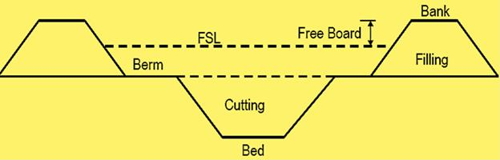

**SideSlopes:** The side slopes should be such that theyarestable, dependingupon the type ofthesoil.Acomparativelysteeperslope canbeprovidedin cuttingratherthaninfilling, as the soil in the former case shall be more stable.

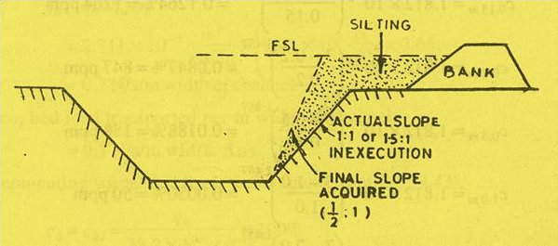

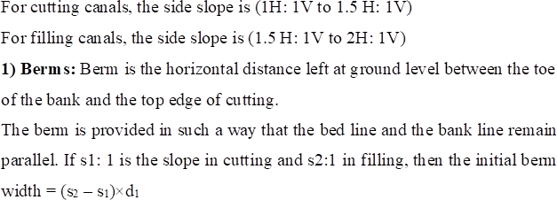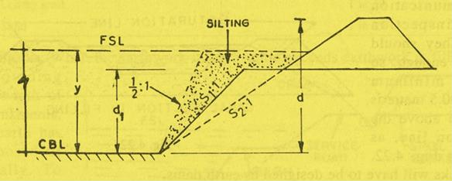

**AdvantageofBerms:**

* 1. Helpthechanneltoattainregimeconditions.
  2. Giveadditionalstrengthtothebanksandprovideprotection againsterosion and breaches.
  3. Protectthebanksfromerosionduetowaveaction.
  4. Provideascopeforfutureexpansionsofthecanal.

**2) Freeboard:** The margin between FSL (full supply level) and bank levelisknownasfreeboard.Theamountoffreeboarddependsuponthe sizeofthechannel.Thegenerallyprovidedvaluesoffreeboardaregiven in the table below:

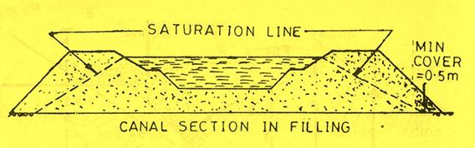**Banks:** The primary purpose of banks in to remain water. This can be used as means of communicationandasinspectionpaths.Theyshouldbewideenough,sothataminimum cover of 0.50 m is available above the saturation line**.**

# CHAPTER-4

**WATERLOGGING**

**INTRODUCTION**

When water table reaches upto ornear to ground level then such a land is called as water logged. Due to waterloggingproductivityof land getsaffected.Waterlogging canbealsoreferredassaturationof soilwith excess of water.

**Effectsofwaterlogging**:

1. Creationofanaerobicconditionsneartherootzone:

Excess of water prevents circulation of air. This will destroy bacteria which will thrive oy under aerobic conditionsandultimatelyleadsinreductionof nitratesandotherchemicalsandthusaffectsthe yield of crops.

1. Normalcultivationoperationssuchastilting,ploughingcannotbeeasilycarriedout.
2. Waterloggingleadstosalinity

Varioussaltscomestothegroundsurfacealongwithwaterresultingindepositionofsaltsinrootzoneof crop. Concentration of these salts has a corroding effects on the roots, which reduces osmotic activity of the plants and thus reduces the plant growth and the plants ultimately fades away. Such soil is called as saline soil.

AlsoRead:BearingCapacityofSoilandIts Importance

**Causes of water logging**. Overandintensiveirrigation.

Improperdrainageofthesurfacerunoff whichresultsinriseinwatertablebypercolation. Infiltration of water into soil from nearby rivers.

Natureorsubsoilwhich maynotallowfreeandeasyflowof subsoilwater. Seepage of water from canals.

Submergenceoftheareabyfloods. Excess of rainfall.

Irregularorflatground profile.

Badeffectoncommunityhealthduetodampclimateandbreedingconditionsformosquitoes.

**Methodstocontrolwaterlogging**.

1. Adequatesurfacedrainage:

Quickremovalofrainwaterbysuitablesurfaceoropendrainisveryimportant measure.

1. Efficientunder-drain:

Providingtiledrainsatsuitabledepthsbelowthesurfaceofthegroundtodisposeofexcessofsubsoilwater.

1. Controllinglossof waterbyseepagefromthecanals:

Thisincludesloweringthe F.S.Lof the canal.Byliningthe canalwithsuitable imperviousmaterial.Byusing irrigation water economically and keeping the intensity of irrigation flow.

1. Increasingtheoutflowandpreventingtheinflow :

Thisiseffectedbyimprovingtheflowconditionsoftheexistingnaturaldrainageandprovidingartificialopenor subsurface grid.

1. Changingthesystemofirrigation:

If thesystemofirrigationisnotproperforthegivenareathenitisverymuchimportanttochangetheirrigation system as per the conditions

1. Pumpingoutsurpluswater:

To prevent the waterloggingof land it isverymuch important topumpoutthe excessof surpluswaterfrom time to time to maintain the fertility and productivity of the land.

1. Preventionofseepagefromreservoir:

Reservoir’sshouldbeproperlymaintainedtopreventtheseepageofwaterfromthereservoir.

1. Liningoffieldchannels:

Properliningof canalsandchannelsshouldbedone.Ifthechannelismadeproperwatertightbyproviding lining then seepage losscan be reduced upto quiet extent**.**

.

### CHAPTER-5

**DIVERSIONHEADWORKSANDREGULATORYSTRUCTURES**

**Diversionheadworks**isastructure constructedacrossariver forthepurpose ofraisingthewaterlevel in

the[river](https://www.cement.org/cement-concrete-applications/water-resources/reservoirs)sothat itcanbediverted intotheofftaking canals. It isalsoknownas[***canalheadworks***](https://cementconcrete.org/water-resources/diversion-head-works-in-irrigation-layout-and-functions-of-component/1778/)andperformsthe following functions.

* Itraisesthewaterlevelonupstreamside.
* Otherusesofthisistoregulatesthesupplyofwaterintocanals.
* Itcontrolstheentryofsiltinto canals.
* Itprovidessomepondagecreatingsmall pond.
* Ithelpsincontrollingthevagariesofriver.

**Componentpartsof Weir/Barrage**

Adiversionheadwork(**orweir**)usuallyconsistsofthefollowingcomponents.

* Weir(orbarrage)proper
* Undersluice
* Dividewall
* Fishladder
* Controlheadregulator
* Siltexcluder,siltejector
* Rivertrainingworks:guidebanks,marginalbunds
* Atypicallayoutofweirorbarrage isshowninthefigure

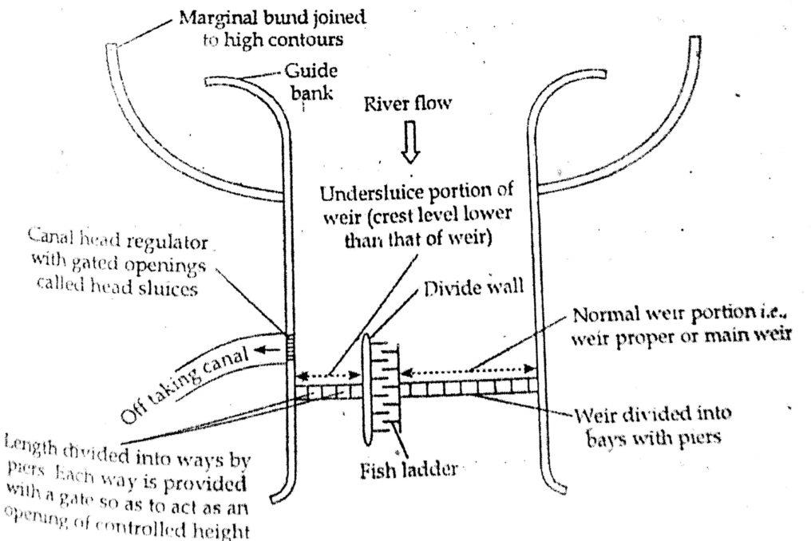[TypicalLayoutofDiversionHeadworks](https://cementconcrete.org/water-resources/diversion-head-works-in-irrigation-layout-and-functions-of-component/1778/)

## Weirorbarrage

**Weir:-**

Aweir isaraisedconcrete( or masonary) crestwallconstructedacrosstheriverwidth.Itmaybeprovidedwitha small shutter on its top. Most of the raising water (ponding) is done by solid wall and very little by shutters.

**Barrage**

Ifpondingofwaterisachievedbyshuttersorgatesthenit iscalledbarrage.It haslowcrestwallwithhighgates.

**Undersluices**

Theweirproper Iconstructed inthemiddleportionofdiversionheadworks.Attheendsundersluicesareprovided adjacent to the anal head regulators. A comparatively less turbulent pocket of water is created near the canal head regulator by constructing under sluice portion of the weir.The undersluices are the openings provided in the weir wall with their crest at low level. These openings are controlled by gates.

**Functionsofundersluices**

* + Toaccertainwellmaintainedriverchannelnearcanalheadregulator.
  + Toscourawaysiltdepositedinfrontofheatregulator;
  + Topassaportionofflood(10to20%)ofdesignfloodduringrainyseason.
  + Helpinimpounding fairamountoffloodtosecurefullstorage.
  + Theyareusedforquicklowering theu/shighfloodevel.

**Dividewall**

Thedividewall ismasonaryoraconcretewallconstructedatrightangle totheaxis oftheweirandsepataresthe weir proper from the under sluices. It extends from beyond the end of the head regulator on u/s side to loose protection of the under sluice on d/s side.

***Functionsofdividewall***:-

* + Toseparatetheundersluiceportionfromweirproperportion.
  + Increasetheeffectivenessoftheundersluicesportion.
  + Topreventcross currentandflowparalleltotheweir.
  + Dividewallincidentallyactsasoneofthesidewallsofthefishladder.
  + Toisolatepocketu/sofheadregulatortofacilitatescouringoperation.

**Fishladder**

Large rivers are generally inhibited byseveral types of fish, many ofwhichare migratorysuch fish has found tobe moving fromu/shill tod/s inthebeginning ofwinter seasoninsearchofwarmerwater andreturntotheir spawning ground u/s, slightly before monsoon in May and June. If no arrangement is made in weir or a dam to enable their migration their life goes in danger. So, for easy moment of the fish from u/s to d/s and again from d/s to u/s fish ladder is constructed. Typical plan of fish ladder is shown in the figure.

**Canalheadregulator**

Acanalheadregulatorisprovidedattheheadofeachmaincanalofftakingfromdiversion headwork.

Itshouldbesoalignedthatits axis makesanangleof90oto120owiththeaxisofweiras showninthefigure.

***Functionsofcanalheadregulator***

* + Itregulatesthesupplyofwaterintocanal.
  + It controlsentryofsiltintocanal.
  + Itpreventstheriverfloodfromenteringthecanal.

**CHAPTER-6**

**CROSSDRAINAGEWORK**

## Definition:

A cross drainage work is a structure carrying the discharge from a natural stream across a canal intercepting the stream. Canal comes across obstructions like rivers, natural drains and other canals. The various types of structures that are built to carry the canal water across the above mentioned obstructions or vice versa are called cross drainage works. It is generally a very costly item and should be avoided by:

* + Diverting onestreamintoanother.
  + Changingthealignmentofthecanalsothatitcrossesbelowthejunctionoftwostreams.

## Typesofcrossdrainageworks

Dependinguponlevelsanddischarge,itmay beofthefollowingtypes:

#### Crossdrainageworkscarryingcanalacrossthedrainage:

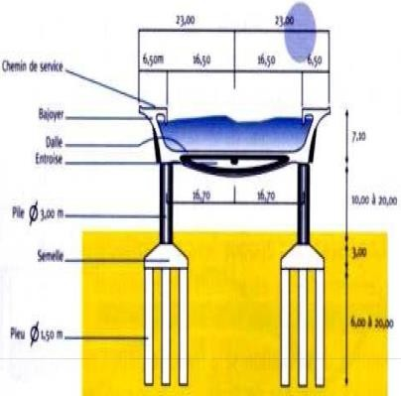

thestructuresthatfall underthistypeare:

1. An Aqueduct
2. Siphon Aqueduct

**Aqueduct:**

WhentheHFLofthedrainissufficientlybelowthebottomofthecanal

suchthatthe drainagewaterflowsfreelyundergravity,thestructureisknownas Aqueduct.

* + Inthis,canalwateriscarriedacrossthedrainageinatroughsupportedonpiers.
  + Bridgecarrying water
  + Providedwhensufficientleveldifferenceisavailablebetweenthecanal andnatural andcanal bed is sufficiently higher than HFL.

[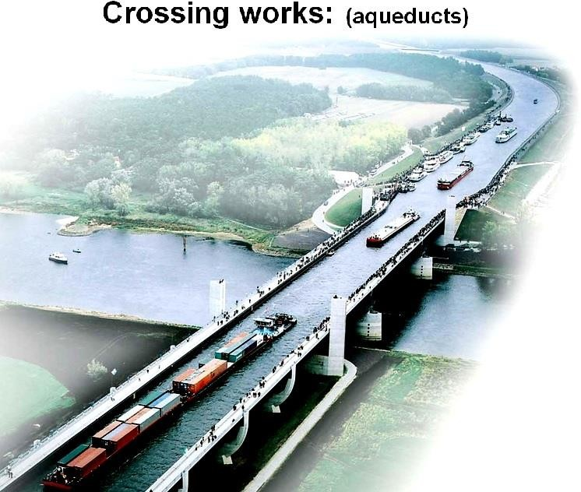](https://www.aboutcivil.org/imajes/aqueduct.jpg)

## SiphonAqueduct:

In case of the siphon Aqueduct, the HFL of the drain is much higher above the canal bed, and water runs under siphonic action through the Aqueduct barrels.

The drain bed is generally depressed and provided with pucci floors, on the upstream side, the drainage bed may be joined to the pucca floor either by a vertical drop or by glacis of 3:1. The downstreamrising slope should not be steeper than 5:1.When the canal is passed over thedrain, the

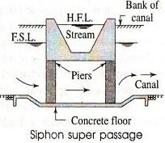canal remains open for inspection throughout and the damage caused by flood is rare. However during heavy floods, the foundations are susceptible to scour or the waterway of drain may getchoked due to debris, tress etc.

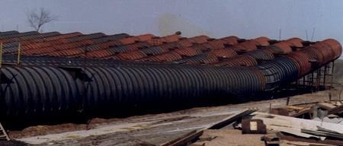

**Crossdrainageworkscarrying drainageovercanal.**

Thestructuresthatfallunderthistypeare:

* + Superpassage
  + Canalsiphonorcalledsyphononly

#### Superpassage:

* + 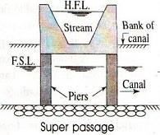The hydraulic structure in which the drainage is passing over the irrigation canal is known as super passage. This structure is suitable when the bed level of drainage is above the flood surface level of the canal. The water of the canal passes clearly below the drainage
  + A super passage is similar to an aqueduct, except in this case the drain is over the canal.
  + The FSL of the canal is lower than the underside of the trough carrying drainage water. Thus, the canal water runs under the gravity.
  + Reverseofan aqueduct

#### CanalSyphon:

* + If two canals cross each other and one of the canals is siphoned under the other, then the hydraulic structure at crossing is called “canal siphon”. For example, lower Jhelum canal is siphoned under the Rasul-Qadirabad (Punjab, Pakistan) link canaland the crossing structureis called “L.J.C siphon”
  + In case ofsiphon the FSL of the canal is much above the bed level of the drainage trough, so that the canal runs under the siphonic action.
  + The canal bedislowered and a ramp is provided at the exit so that the trouble of silting is minimized.
  + Reverseofanaqueductsiphon
  + In theabovetwo types, theinspectionroadcannot beprovidedalongthe canal and aseparate bridgeis required for roadway. For economy, the canal may be flumed but the drainage trough is never flumed.

**CHAPTER-7**

**DAM**

Types of Impounding structures - Gravity dam – Forces on a dam -Design of Gravity dams; Earth dams, Arch dams- Diversion Head works - Weirs and Barrages.

##### Impoundingstructure

* + - Impounding structure or dam means a man-made device structure, whether a dam acrossa watercourse or other structure outside a watercourse, used or to be used to retain or store waters or other materials.
    - The term includes: (i) all dams that are 25 feet or greater in height and that create an impoundment capacity of 15 acre-feet or greater, and (ii) all dams that are six feet or greater in height and that create an impoundment capacity of 50 acre-feet or greater.

##### Diversionheadwork.

* + - Anyhydraulicstructure,whichsupplieswatertotheoff-takingcanal,iscalledaheadwork.
    - Adiversionheadworkservestodiverttherequiredsupplyintothecanalfromtheriver.

##### Thepurposesofdiversionheadwork.

* + - 1. Itraisesthewaterlevelintheriversothatthecommandedareacanbeincreased.
      2. Itregulatestheintakeofwaterintothecanal.
      3. Itcontrolsthesiltentryintothecanal.
      4. Itreducesfluctuationsinthelevelofsupplyintheriver.
      5. Itstoreswaterfortidingoversmallperiodsofshortsupplies.

##### Weir

The weir is a solid obstruction put across the river to raise its water level and divert the water in to the canal. If a weir also stores water for tiding over small periods of short supplies, it is called a storage weir.

##### Thecomponentpartsofdiversionheadwork

* + - * + Weirorbarrage
        + Dividewallordividegroyne
        + Fishladder
        + Headsluiceorcanalheadregulator
        + Canaloff-takes
        + Floodbanks
        + Rivertrainingworks.

##### Dam

Adamisahydraulicstructureconstructedacrossarivertostorethesuppliyforalongerduration

andreleaseitthroughdesignedoutlets.

##### TypesofDams

**BasedonMaterialsofConstruction**

* + - * + Rigid.
        + Non-Rigid.

##### BasedonStructuralBehaviour

* + - * + GravityDam.
        + ArchDam.
        + ButtressDam.
        + Embankment Dam.

##### BasedonFunctions

* + - * + StorageDam.
        + DetentionDam.
        + DiversionDam.
        + Coffer dam.

##### BasedonHydraulicBehaviour

* + - * + OverFlowDam.
        + NonOverFlowDam.

##### GeneralTypes

* + - * + Solidgravitydam(masonry,concrete,steelandtimber)
        + Archdams
        + Buttressdams
        + Earthdams
        + Rockfilldams
        + Combinationofrockfillandearthdams

##### Gravitydam

* + - A gravity dam is a structure so proportioned that its own weight resists the forcesexertedupon it. It requires little maintenance and it is most commonly used.
    - AGravitydam has beendefinedasa“structurewhichisdesignedinsuchawaythat its ownweight resist the external forces”.
    - Thistypeofastructureismostdurableandsolidandrequiresverylessmaintenance.
    - SuchdamsareconstructedofmasonryorConcrete.
    - However,concretegravitydamsarepreferredthesedaysandmostlyconstructed.
    - Thelineoftheupstreamfaceorthelineofthecrownofthedamiftheupstreamface issloping, is taken as the reference line for layout purpose etc. and is known as the Base line

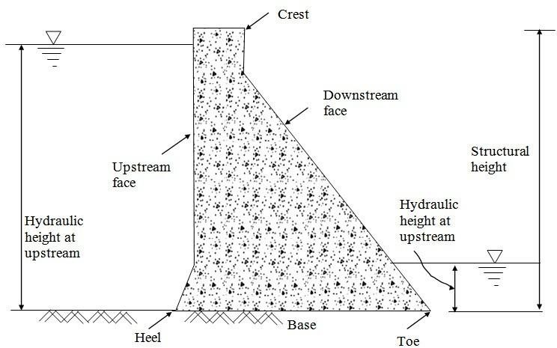of the damor the “Axis ofThe Dam”When suitable conditions are available such dams can be constructed up to great heights.

##### Thedifferentcomponentsofasolidgravitydamare

* + - Crest.
    - FreeBoard.
    - Heel.
    - Toe.
    - SluiceWay.
    - DrainageGallery.

##### TypicalcrosssectionofgravityDam:

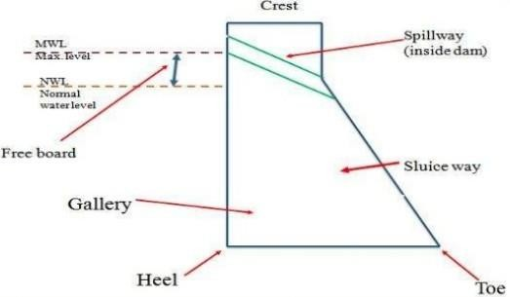

**Heel:**contactwiththegroundontheupstreamside

**Toe:**contactonthedownstreamside

**Abutment:**Sidesofthevalleyonwhichthestructureofthedamrest

**Galleries:**smallroomslikestructureleftwithinthedamforcheckingoperations.

**Diversiontunnel:** Tunnelsareconstructedfordivertingwaterbeforetheconstructionofdam.This helps in keeping the river bed dry.

**Spillways:**Itisthearrangementnearthetoptoreleasetheexcesswaterofthereservoirtodownstream side

**Sluice way:** An openingin the damnear the ground level, which is used to clear the silt accumulation in the reservoir side.

##### ForcesActingonGravityDam

TheVariousexternalforcesactingonGravitydammaybe:

* WaterPressure
* UpliftPressure
* PressureduetoEarthquakeforces
* SiltPressure
* WavePressure
* IcePressure
* Thestabilizingforceistheweightofthedamitself

##### SelfweightoftheDam

Selfweightofagravitydamismainstabilizingforcewhich counterbalancesalltheexternalforces acting on it.

Forconstructionof gravitydamsthespecific weightofconcrete &stonemasonry shouldn’tbeless than 2400 kg/m3& 2300 kg/m3respectively.

Theselfweightofthegravitydamactsthroughthecentreofgravityofthe. Its calculated by the following formula – *W*=*γmX Volume*

Whereγmisthespecificweightofthedam’smaterial.

##### Waterpressure

* + - Waterpressureontheupstreamsideisthemaindestabilizingforceingravitydam.
    - Downstreamsidemayalsohavewaterpressure.
    - Thoughdownstreamwater pressure producescounteroverturningmoment,itsmagnitude

is much smaller as compared to the upstream water pressure and therefore generally not considered in stability analysis.

* + - WaterPressureisthemostmajorexternalforceactingonagravitydam.
    - Onupstreamfacepressureexertedbywaterisstoreduptothefullreservoirlevel. Theupstream face may either be vertical or inclined.
    - Ondownstreamfacethepressureisexertedbytailwater.Thedownstreamfaceisalways

inclined.Itiscalculated bythefollowingformula–*P*=1*γ*

2 *w*

*xh*2

Whereγwistheunitweightofwater&histheheightofwater.

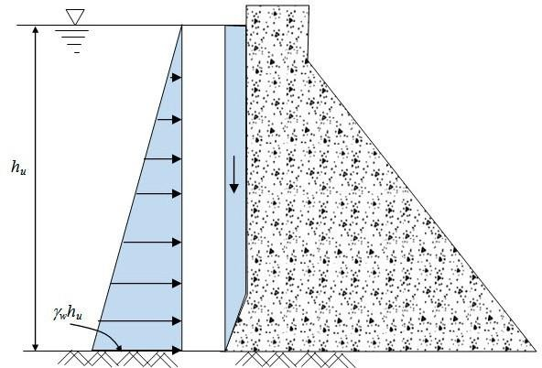

##### Upliftwaterpressure

* + - TheupliftpressureistheupwardpressureofwateratthebaseofthedamasshowninFigure

29.3.Italsoexistswithinanycracksinthe dam.

* + - Thewaterstored on theupstreamsideof thedamhasatendency to seep throughthe soilbelow foundation.
    - Whileseeping,thewaterexertsaupliftforceonthebaseofthedamdependingupon thehead of water.
    - Thisupliftpressurereducestheselfweightofthedam.
    - Toreducetheupliftpressure,drainagegalleriesareprovidedonthebaseofthedams.
    - Itiscalculatedbythefollowingformula –*U*=1*γ*

1. *wxhxB*

Where‘B’isthewidthofthebaseofthedam.

##### WavePressure

Whenveryhighwindflowsoverthewatersurfaceofthereservoir,wavesareformedwhichexert

pressureontheupstreampartofthedam. The magnitude of waves depend upon –

* + - 1. Thevelocityofwind.
      2. DepthofReservoir.
      3. AreaofWaterSurface.

Itiscalculatedbythefollowingformula- *Pv*=2.4*γwxhw*

Where‘hw’isthewaveheight.

##### WINDPRESSURE:

* + - The top exposed portion on the dam is small & hence the wind pressure on this portionofdam is negligible.
    - Butstillanallowanceshouldbemadeforthewindpressureattherateofabout150kg/m2

fortheexposedsurfaceareaoftheupstream&downstreamfaces.

##### SEISMICFORCES:

* + - Damsaresubjectedtovibrationduringearthquakes.
    - Vibration affects both the body of the dam as well as the water in the reservoir behindthedam.
    - Themostdangereffectoccurswhenthevibrationisperpendiculartothefaceofthedam.
    - BodyForces:Bodyforceactshorizontallyatthecenterofgravityandiscalculatedas:

*Pem*=*αxW*

* + - WaterForce: Watervibrationproducesaforceonthedamactinghorizontally&calculated

by:*Pew*

=2*C*

1. *e*

*αh*2

##### ELEMENTRYPROFILE

* + When water is stored against any vertical face, then it exerts pressure perpendicular totheface which is zero at top & maximum at bottom.
  + Therequiredtopthicknessisthuszero&bottomthicknessismaximumforminga rightangled triangle with the apex at top, one face vertical & some base width.
  + Twoconditionsshouldbesatisfiedtoachievestability
    - **When empty -** The external force is zero & its self weight passes through C.G. of the triangle.
    - **WhenFull-**Theresultantforceshouldpassthroughtheextremerightendof themiddlethird.

Thelimitingconditionis– *h*= *σc*

*γ*(1+*S*)

* + where,σc=allowablecompressivestressc=allowablecompressivestress

##### PracticalProfile

* + Variousparametersinfixingtheparametersofthedamsectionare,
  + Free Board –IS 6512, 1972 specifies that thefree board willbe 1.5 times the waveheightabove normal pool level.
  + Top Width – The top width of the dam is generally fixed according to requirements oftheroadwayto be provided. The most economical top width of the dam is 14% of its height.
  + BaseWidth–Thebasewidthofthedamshallbesafeagainstoverturning,sliding&no tension in dam body.

Forelementaryprofile–

* + - Whenupliftisconsidered, *B*=*h*

√*S*

* + - Whenupliftisn’tconsidered *B*= *h*

√*S*−1

##### LowGravityDam

* + Alowgravitydamisdesignedonthebasisifofelementaryprofile,wheretheresultant forcepasses through the middle-third of its base.
  + Theprincipalstressisgivenby–σc=allowablecompressivestress=γH(S–C+1)Where,σc=allowablecompressivestress=principalstress,γ=unit weight, S=Specific Gravity and C=A constant.
  + The principal stress varies with ‘H’as all other terms are constant. To avoid failure of thedamthevalueof‘σc=allowablecompressivestress’shouldn’texceedallowableworkingstress(f).F=γH(S–C+1)

##### HighGravity Dam

* + The high gravity is a complicated structure, where the resultant force may pass throughapoint outside the middle-third of the base.
  + The section of the dam is modified by providing extra slope on the upstream anddownstream side.
  + Theconditionforthehighgravitydamare *H*> *f*

*w*(*S*+1)

–Where,f=allowableworking

KIIT

POLYTECHNIC

stress.

##### FailureofGravityDam

Failureofgravitydamsarecauseddueto,

Sliding–Itmaytakeplaceonahorizontaljointaboveformation,

REFERENCES:**FLUIDMECHANICS(R.KBANSAL)**

**IRRIGATIONENGINEERING(N.N.BASAK)**